**Blind River District Health Centre Requirements Document**

*Team 3 members: Marki, Reshma, Ryan, Jagsir and Krunal*

**Section 1 - Introduction**

This requirements document goes into great detail in describing the necessary preliminary steps taken by our team in developing your hospital website. Our main goal is providing you with a fully functional, database driven web application that will also function as your website and primary online footprint. Therefore, the purpose of this requirement’s document is to provide you with a general framework or blueprint for the strategies we’ll be using when developing you’re web site.

What you will find outlined below are the primary assets and layouts for the major features of the website, including a content plan, database schemas, our rational and design philosophies, and handover plan. Extensive research done about potential users from in and around the Hospital community has also been included, as well as a development schedule and maintenance plan. All of this will provide a richer understanding of the perspective we’ve taken while undergoing the development of the project.

**Section 2 - Rationale and project goals**

Latest studied showed that traffic on the web is increasing on mobile phones and tablets. Roughly 20 percent of people trying to contact the hospital in an emergency are on the move. Also, users have come to expect responsiveness on any device.

The BRDHC website is laid out to be clear, concise and responsive. For the navigation, a horizontal navigation is used on desktops, an altered version is for tablets, and a dropdown button is used for smartphones. Font and buttons are also formatted to be easily readable and clickable on all devices. Card sorting exercises were used to create an intuitive navigation experience for users. This allows visitors to quickly find information.

**Section 3 - Database schema**

The data schemas are included in the individual feature sections of Section 9.

**Section 4 - Content plan**

*4.1 Navigation Scheme*

BRDHC’s main navigation scheme is consistent across all public and admin web pages.

Here is our final content map that displays our main navigation from our card sorting exercise.

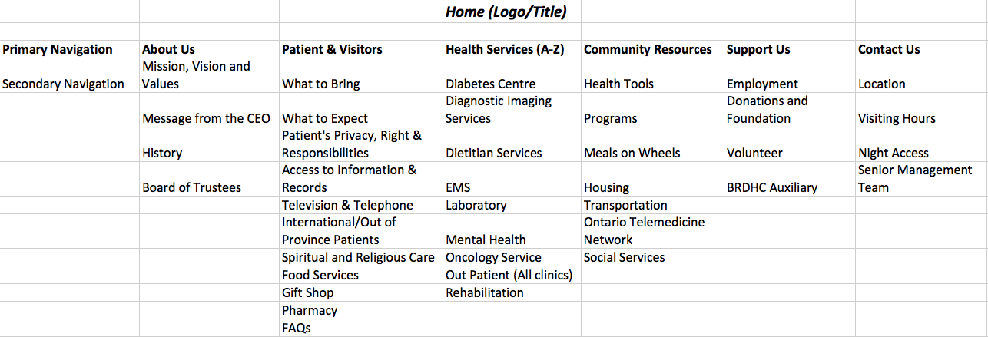

***4.1.1.1 Primary Navigation***

Considering primary navigation to be the navigation always available to the user from every page, it would include links to the following**:**

About us

Patients & Visitors

Health Services (A-Z)

Community Resources

Support Us

Contact Us

**4.1.1.2 Secondary Navigation**

Mission, Vision & Values

Message from the CEO

History

Board of Trustees

-

What to Bring

What to Expect

Patient’s Privacy, Rights & Responsibilities

Access to Information & Records

Television & Telephone

International/Out of Province Patients

Spiritual and Religious Care

Food Services

Gift Shop

Pharmacy

FAQS

-

Diabetes Centre

Diagnostic Imaging Services

Dietitian Services

EMS

Laboratory

Mental Health

Oncology Service

Out Patient (All clinics)

Rehabilitation

-

Health Tools

Programs

Meals on Wheels

Housing

Transportation

Ontario Telemedicine Network

Social Services

-

Employment

Donations and Foundation

Volunteer

BRDHC Auxiliary

-

Location

Visiting Hours

Night Access

Senior Management Team

***4.1.1.3 Admin Dashboard Navigation***

The admin pages have an additional dashboard navigation that changes depending on the authorization level of that admin user.

***4.1.1.4 Footer Navigation***

This navigation is available on the footer:

Site Privacy

Copyright

Term of use

Finance

Accreditation

Public Reporting

*4.2 Naming Conventions*

The general naming convention followed throughout is to have camel casing where the first letter starts with a lowercase.

***4.2.1 File names***

The files were named on the basis of the feature. All the files belonging to one feature are named to begin with the feature name.

***4.2.2 Link Names***

The link names are same as the feature names.

***4.2.3 URL Patterns***

root/feature

root/Admin/feature

***4.2.4 Feature Names***

Below is a list of the features:

Gift Shop

Volunteer

Health Tools Quiz

Careers

Contact Us

Calendar

Emergency Wait Time

Invoice Management

Appointments

Find a Doctor

Make a Donation

Feedback Survey

Prescriptions

Health Alerts

*4.3 Content*

For the registration section, information about the doctor specialties and name of all the departments in the hospital is coming from the client. These two things need to be populated in dropdown lists for the registration of doctors.

The gift shop and health tools quiz come with default content. The admin user can add, update or delete this content as they see fit. The volunteer opportunities page comes with two default listings. The admin can add, update and delete opportunities as they become available.

For emergency, appointments and invoice management no particular content is required from the client. The content for these features are from the database that will capture data when the application is used

The events calendar, contact us, and careers pages will require content from the client. The Community Admin will create events, and contact information will be required for the primary contacts of the hospital. The client will also determine careers whenever a job is available. Mock information will be used as means to display the functionality of each feature.

Find a doctor will require content from the client. For make a donation and feedback survey there would be no particular content that would be coming from client.

**Section 5 - User roles**

The roles have been divided among different departments so that each activity is independent of the other and it is easier to claim responsibilities for actions.

|  |  |  |
| --- | --- | --- |
| **Roles** | **Rules** | **Rationale** |
| Administration | Can access every feature | Monitors every feature |
| Doctor | Manage appointments  Make invoices | To manage direct interactions with the patient. User with this role may be the doctor or the doctor’s staff |
| Patient | Request for appointments  Make payments | Facilities with this role make the patient less |
| EmergencyAdmin | Updates emergency wait times | In charge of emergency department |
| CommunityAdmin | Post upcoming events and manage them | The events conducted at BRDHC are completely managed by the BRDHC community group |
| AlertAdmin | Manages alert messages | In situations that need announcing alerts this admin can have quick access to the system. |
| ContactAdmin | Manages Contact information and receives email when contact form is filled and submitted. | This role was made for the management team that would take care of direct communication with the users. |
| EducationAdmin | Manages the health Quiz | The quiz needs to be updated often and the team looking into this should not have access to other critical information. |
| GiftShopAdmin | Manages the sale of gift cards and bouquets | Even though the gift shop is a part of the hospital it is a completely different department where the admin controls the system. |
| HumanResources | Manages the recruitment process | The recruitment team holds an independent process, hence, the role. |

**Section 6 - Third party libraries and code**

Below are the 3rd party libraries used for building this app:

6.1 DayPilot

1. version - Build 7.7
2. link - http://www.daypilot.org/daypilot-lite.html
3. use - calendar used in events, careers and contact us

6.2 FreeTextBox

1. version - 3.3.1
2. link - <http://freetextbox.com/>
3. use - admin can use it for writing content for alert

6.3 PayPal

a. link - <http://paypal.com>

b. use - payment system for gift purchase, invoice management and donations

**Section 7 - Master pages**

Jagsir is hosting the website at <http://www.brdhchumber.com/>

The website is hosted at winhost.com with Visual Studio 2012, IIS 8.0, and SqlServer 2012. Other things are unlimited disk space, unlimited bandwidth, and 2GB database storage.

1. brdhc.master

location - root level[.](http://paypal.com)

[use - this is](http://paypal.com) used on all registered user pages and admin pages. This master page has web user control for secondary navigation which is database driven.

2. site.master

location - root level[.](http://paypal.com)

[use - this is](http://paypal.com) used on all public user pages.

3. msHomeMaster.master

location - root level

use - this is used for the home page

**Section 8 - CSS files**

In App_Themes folder there are two themes, HealthTools and Theme. These two themes contain all the css file as listed below:

App_Themes/HealthTools/healthTools.css

-healthTools.css

-responsiveGrid.css

App_Themes/Theme/bills.css

-contactUs.css

-dashBoard.css

-home.css

-menu.css

-normalize.css

-registrationStyles.css

-tableTemp.css

# 

# Section 9 - Features

# Krunal: Feature – Find a Doctor

Find a doctor is a feature with the help of which a Patient can search a doctor by name or by their specialty. They should be logged-in, to see the link. A patient can also view full profile of a doctor including his email and phone number. From that there is a make an appointment link with which patient can book an appointment.

The feature has admin view too. An admin can view all the doctor records; also he can insert a new doctor when he joins the hospital. When information needs to be deleted or changed, admin can do that too.

|  |  |
| --- | --- |
| Primary Key | Numeric |
| Name | Varchar(50) |
| Username | Varchar(50) |
| Date of Birth | Date |
| Identification | Varchar(50) |
| Department | Char(50) |
| Join Date | Date |
| Specialty | Varchar(50) |
| Email | Varchar(50) |
| Phone | Varchar(50) |
| Image | Image |

*Find a Doctor*

brdhc_UserbasicInfo table is used by the Admin to insert different users and has a relation with brdhc_DoctorSpecialities table. UserBasicInfoId is the primary key and speciality is the Foreign key.

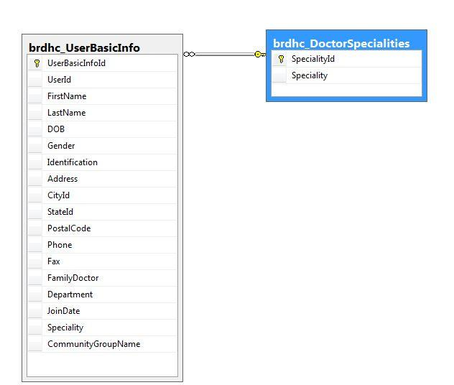

**Flow chart Find-a-Doctor User View**

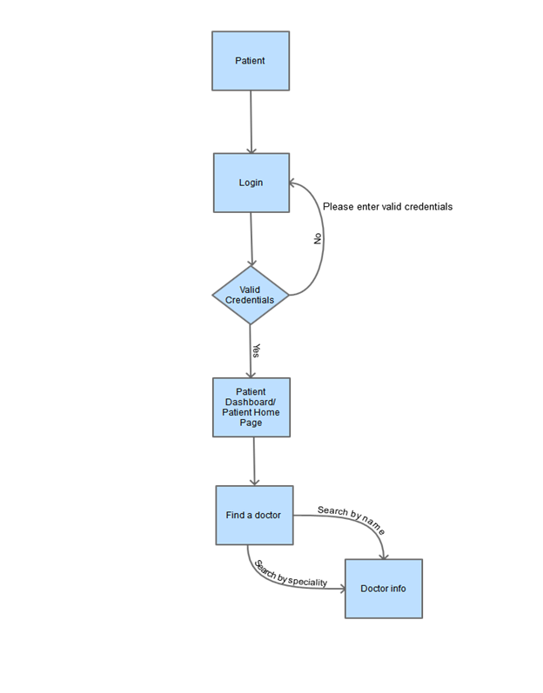

**Flow chart** **Add-Doctor-Admin View**

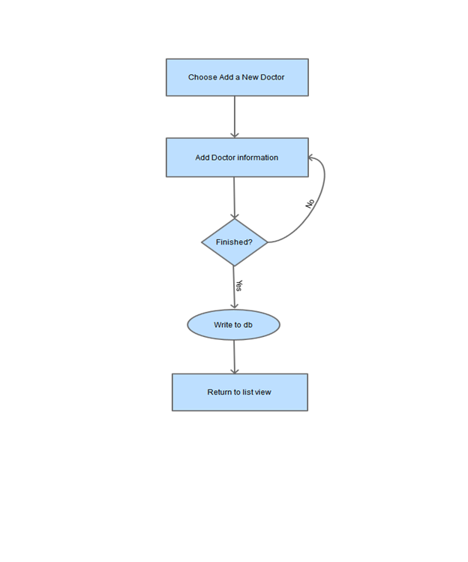

**Flow chart** **Update-Doctor-Admin View**

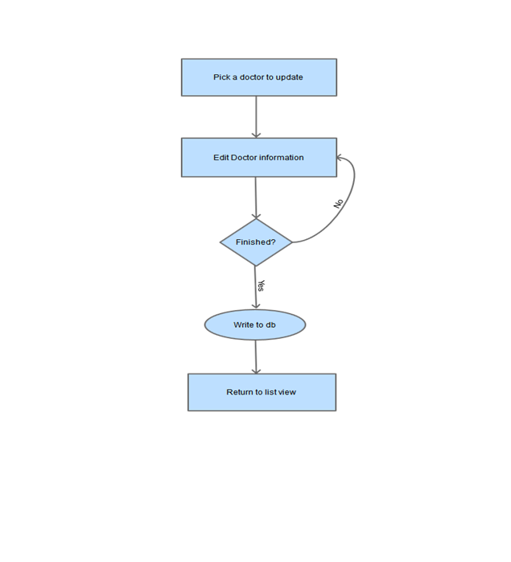

**Flow chart** **Delete-Doctor-Admin View**

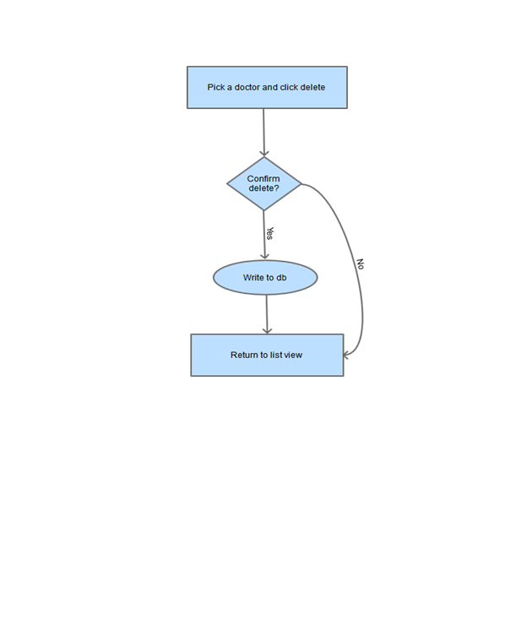

**Wireframes**

**User view:**

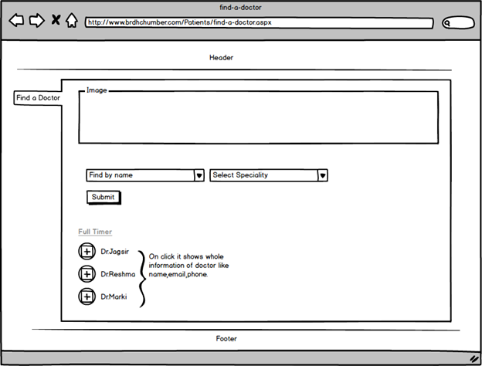

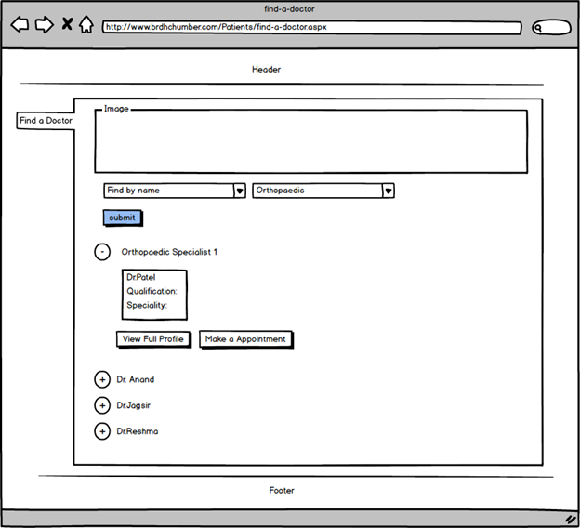

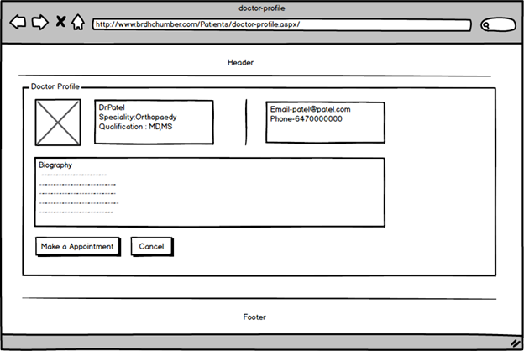

**Admin view:**

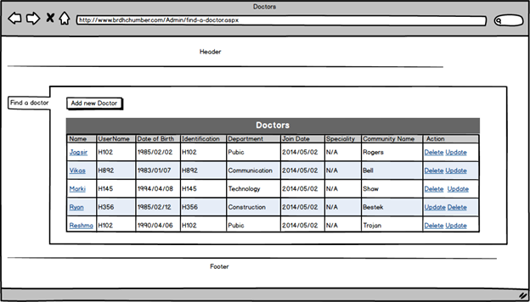

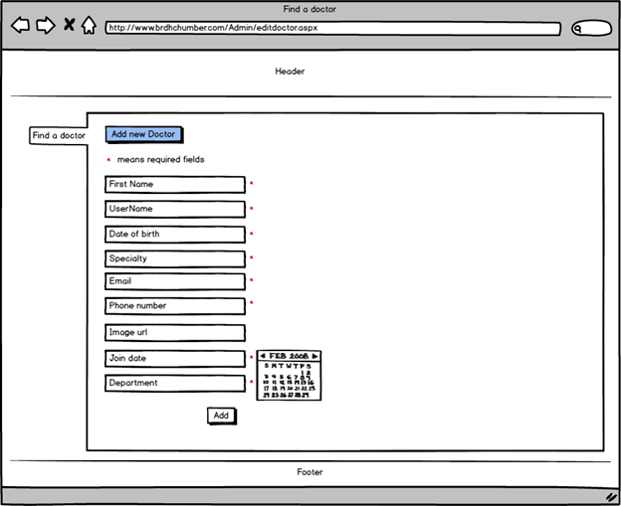

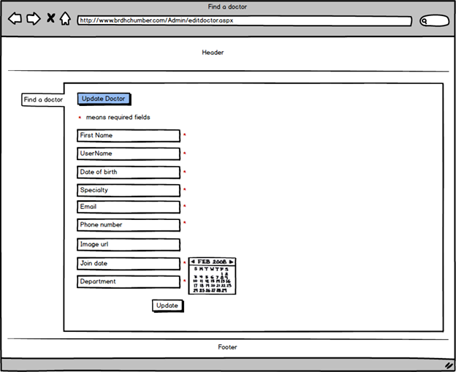

# Krunal: Feature - Make a Donation

This feature also has two views. Admin View and User View. A user who is interested in donating money can donate money through secure online process. She/he can donate to the specific department of the hospital. The donation process uses Sandbox (PayPal) for secure online transactions. When User completes the donation process an automated tax receipt is generated and the information is stored in the database. Also PayPal sends an email of transaction confirmation to the user.

On the Admin side, one is able to view the records of the donor’s and delete the records if required. A direct email can be send to the donor if required.

|  |  |
| --- | --- |
| Primary Key | Numeric |
| Name | Varchar(50) |
| Gender | Char(10) |
| City | Varchar(50) |
| State | Varchar(50) |
| Mobile | decimal |
| Email | Varchar(50) |
| Amount | Decimal |

**Flow chart** **Make a Donation User view**

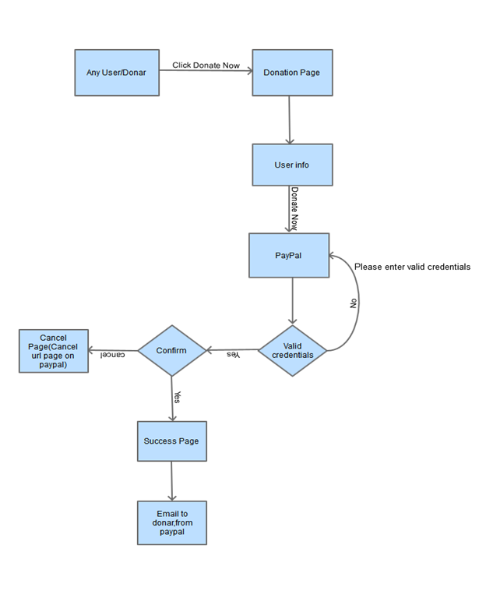

**Flow chart** **Make a donation Admin view**

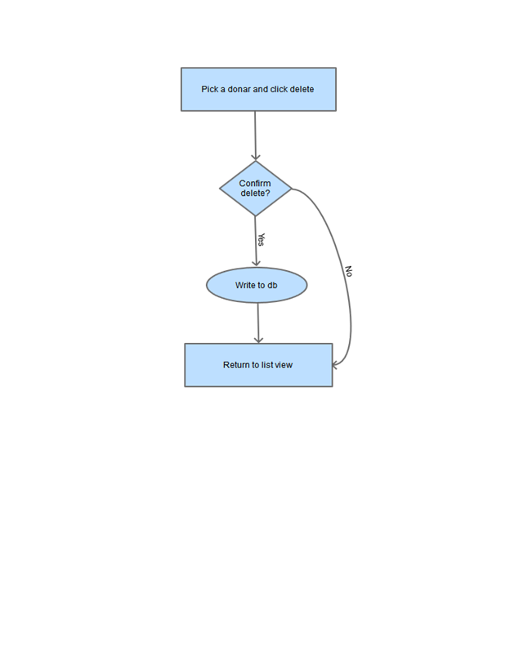

**Wireframes:**

# User view

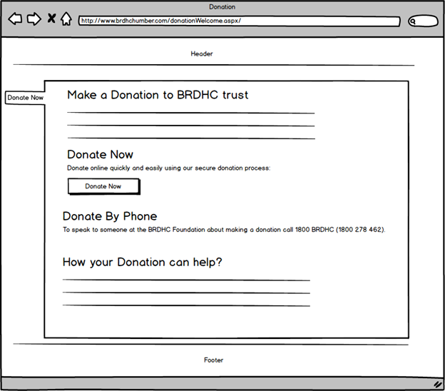

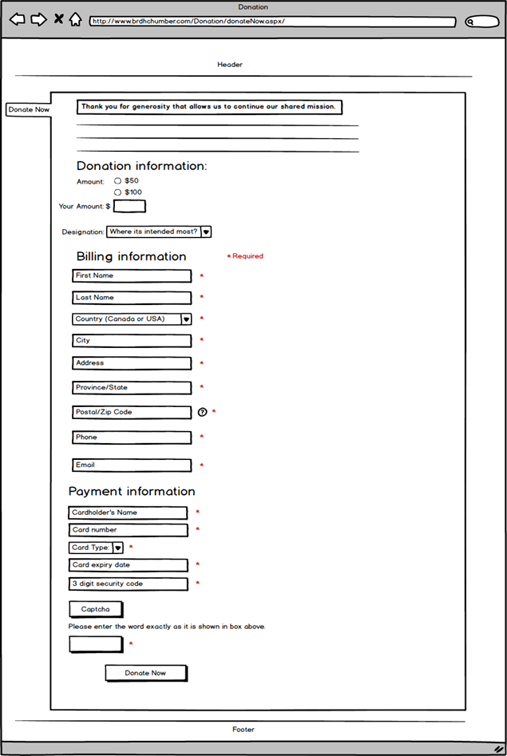

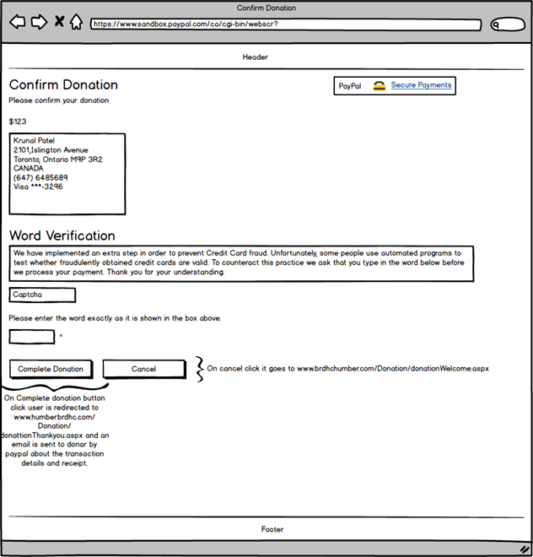

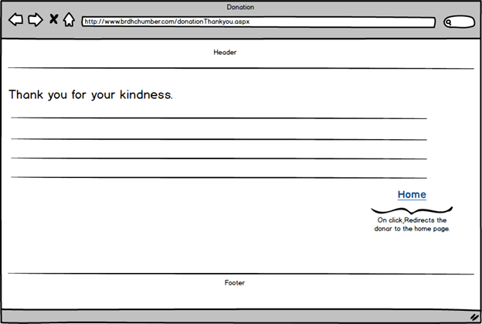

**Admin view**:

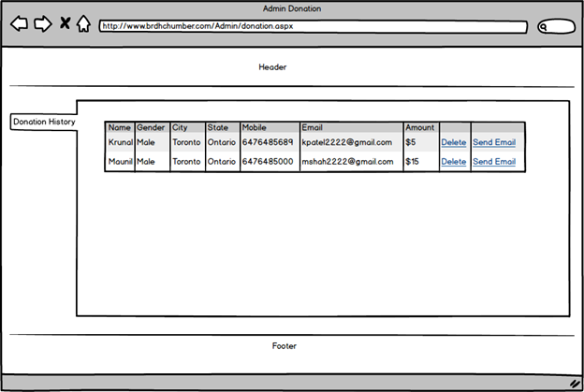

# Krunal: Feature - Feedback Survey

Using this feature a person can give feedback about the hospital and the hospital website. This will help the management to improve in both if required. The user just have to fill a form and submit it which will be stored in the database. When the user submits the survey they will get an email thanking them.

On the admin side he can view all the surveys submitted by people and delete them if not required. Also one can reply back to the sender if necessary.

|  |  |
| --- | --- |
| Primary Key | Numeric |
| Name | Varchar(50) |
| Gender | Char(10) |
| City | Varchar(50) |
| State | Varchar(50) |
| Mobile | decimal |
| Email | Varchar(50) |
| Feedback | Varchar(max) |

**User Feedback**

User feedback is stored in brdhc_Feedback table and feedbackId is the primary key. This table does not have any relationship with other tables.

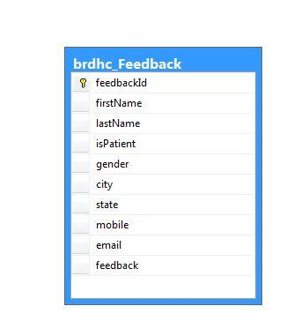

**Flow chart** **Feedback-Survey User view**

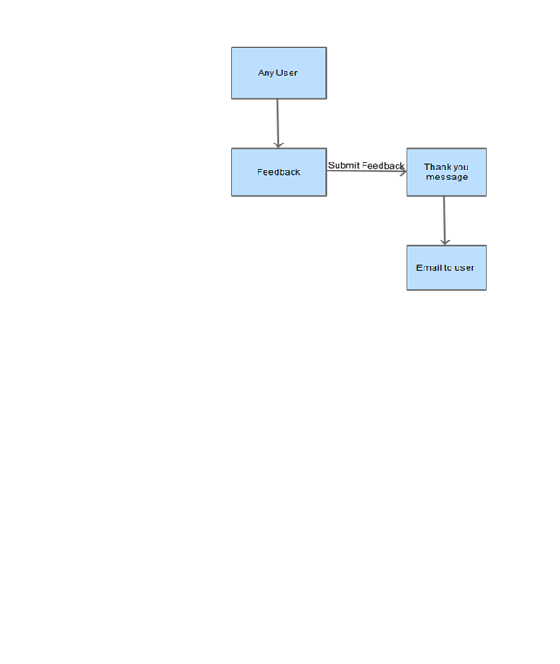

**Flow chart** **Feedback Survey Admin**

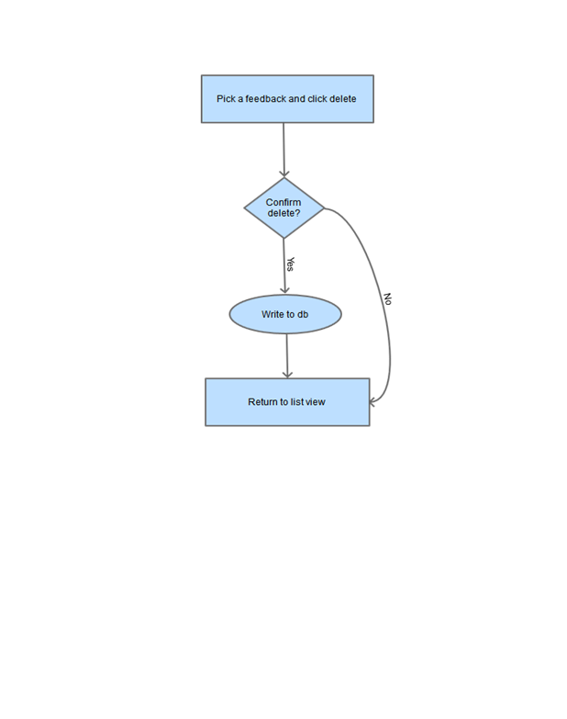

**Wireframes:**

**User view**

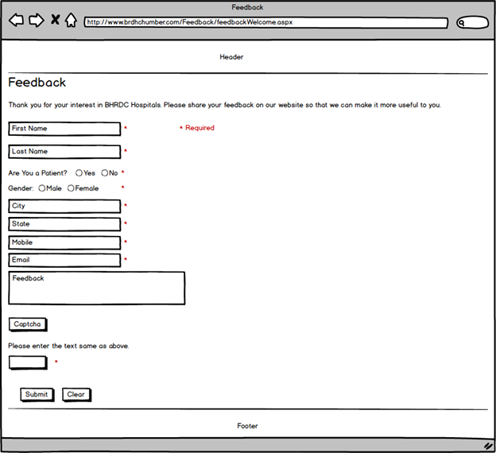

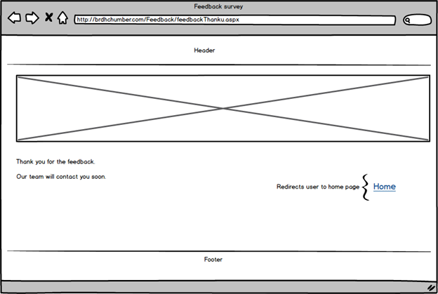

**Admin view**

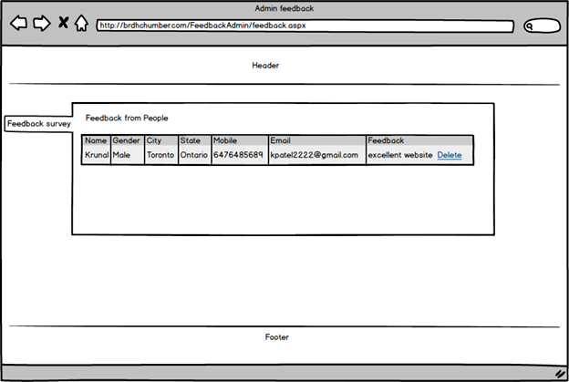

**Reshma**: **Feature - Booking Appointments**

The booking appointments feature is meant for patients to make appointment requests with doctors at the hospital. After a patient logs in he is redirected to the patient dashboard where he can click on a link called ‘Appointments’. Here he can view upcoming appointments, make a request for an appointment and view request pending requests.

This feature will have an administrative backend managed by the doctor’s admin and the super admin. The super admin has the same rights as the doctor admin. Admins can log in into the website and send replies to requests from the patients. The admin can also create an appointment.

Table: brdhc_PatientAppointments

|  |  |
| --- | --- |
| AppointmentID | Numeric – Primary Key |
| PatienUserId | uniqueidentifier |
| DcotorUserId | uniqueidentifier |
| Reason | Text 255 characters |
| Appointment Date | Date |
| Appointment Time | DateTime |
| CreatedOnDate | Date |
| approvalStatus | Text 100 characters |

Table: aspnet_Users

|  |  |
| --- | --- |
| User Id | Unique Identifier (PK) (Auto Generated) |
| Application Id | Unique Identifier (FK) |
| User Name | Text 256 characters |
| Mobile Alias | Text 16 characters |
| Is Anonymous | True / False |
| Last Activity Date | Date |

Tables: brdhc_UserBasicInfo

|  |  |
| --- | --- |
| User Basic Info Id | Unique Identifier **(PK)(Auto Generated)** |
| User Id | Unique Identifier **(FK)** |
| First Name | Text 50 characters |
| Last Name | Text 50 characters |
| Date of Birth | Date |
| Gender | Text 1 characters |
| Identification | Text 20 characters |
| Address | Text 100 characters |
| City ID | Unique Identifier **(FK)** |
| State Id | Unique Identifier **(FK)** |
| Postal Code | Text 7 characters |
| Phone | Text 15 characters |
| Fax | Text 15 characters |
| Family Doctors | Text 50 characters |
| Department | Text 50 characters |
| Join Date | Date |
| Speciality | Text 50 characters |
| Community Group Name | Text 100 characters |

All the appointments are saved in one table brdhc_PatientAppointments but this table has relationship with other two tables aspnet_Users and brdhc_UserBasicInfo. This is the preimary-foriegn key relationship and user id fields is used for this purpose. brdhc_UserBasicInfo table is used to display first name, last name, and identification (as Health Card) in appointment listing andbooking webpages.

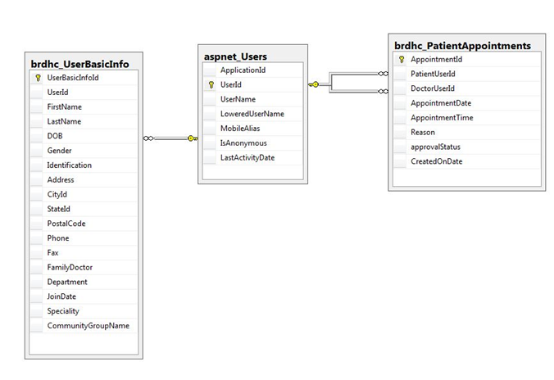

**The data flow models:**

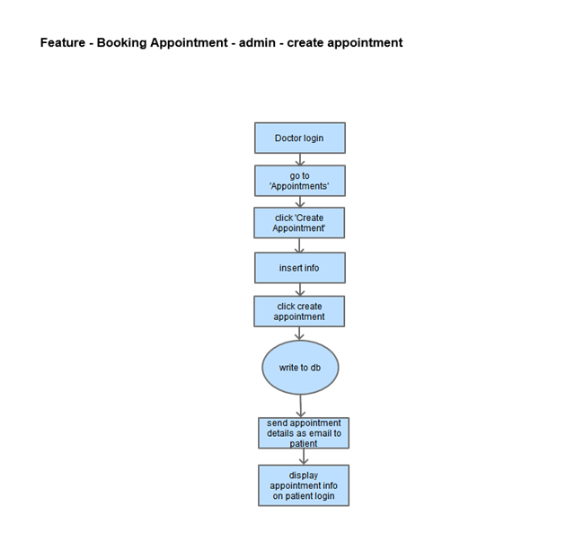

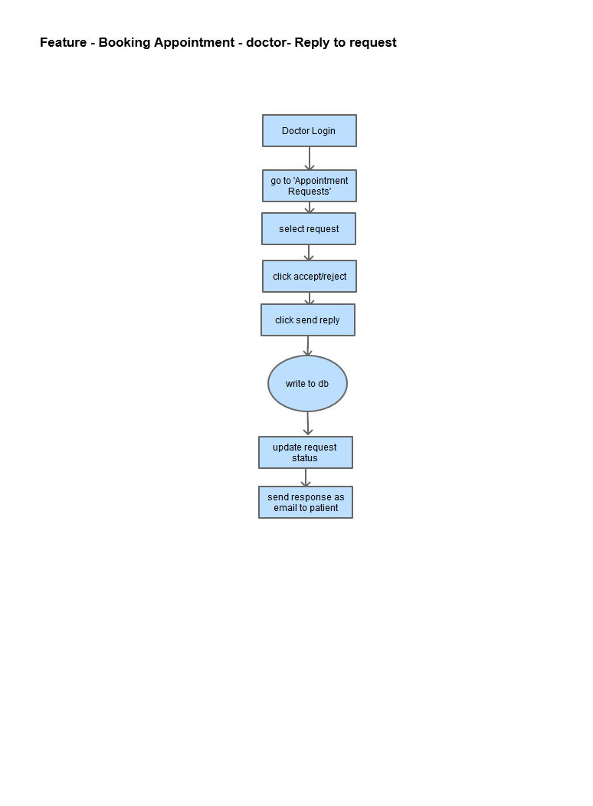

**Wireframes:**

**The data flow models:**

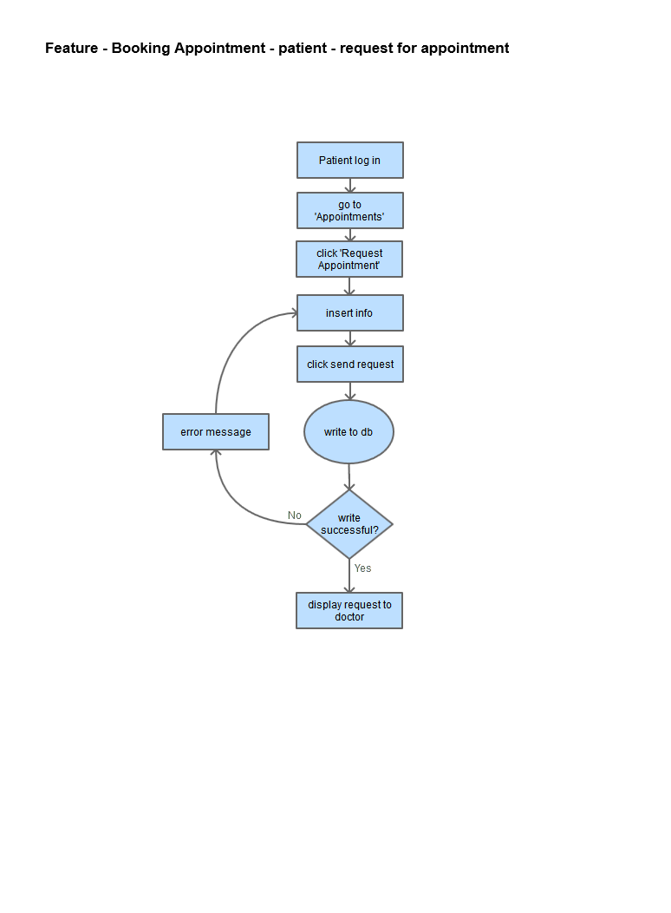

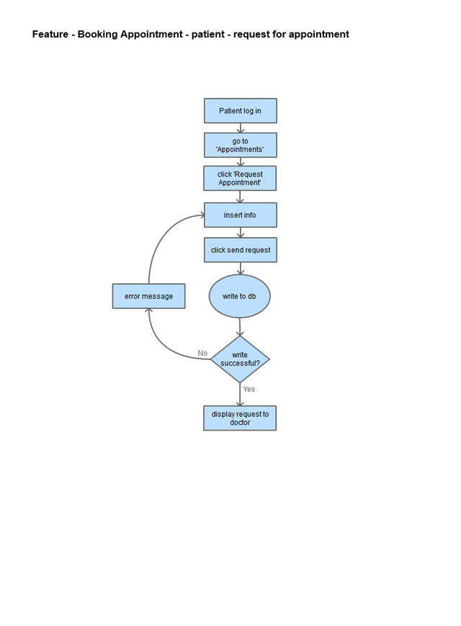

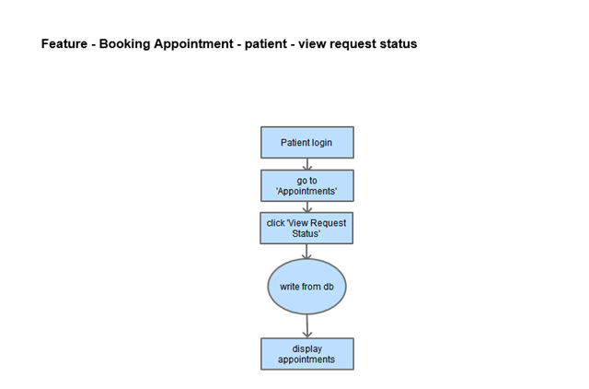

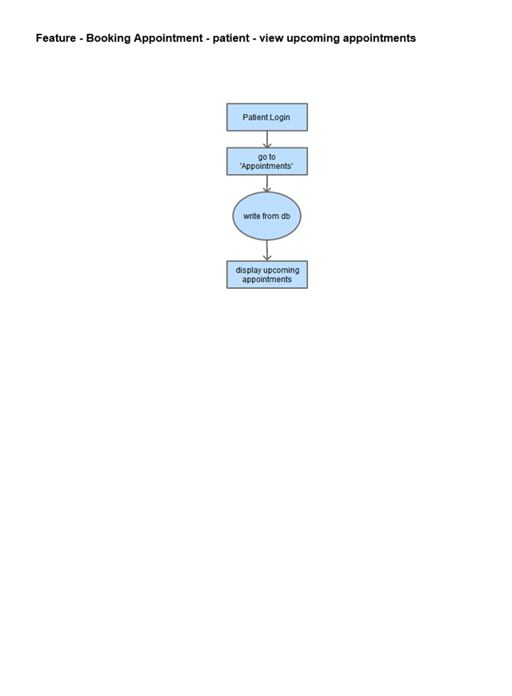

**Wireframes:**

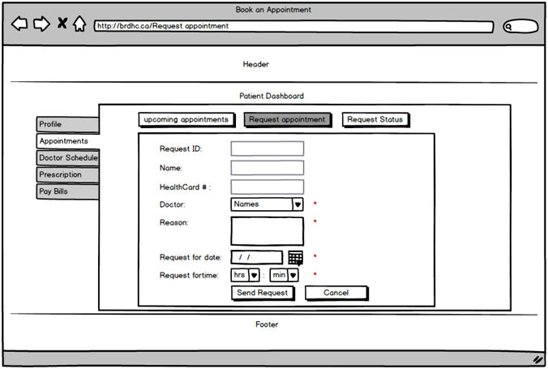

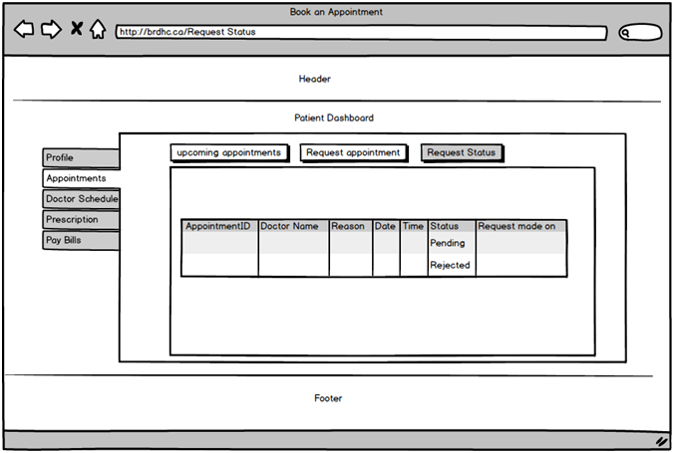

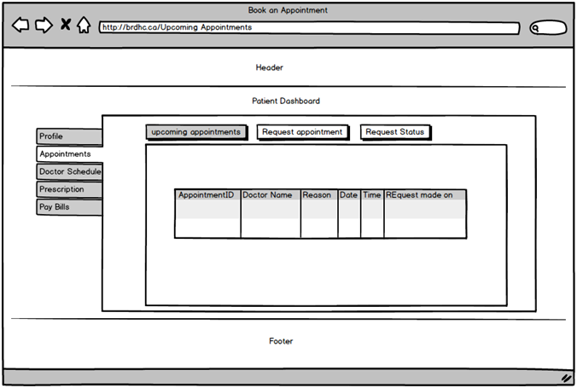

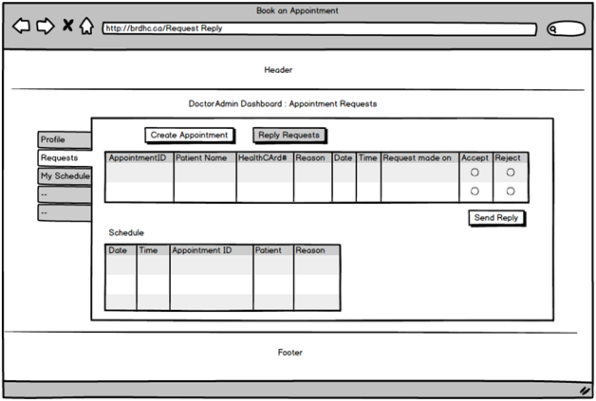

**Reshma: Feature - Emergency Room Wait Time**

The emergency wait time helps the patient identify the wait time at the emergency unit of the hospital. The patient needs to log in to know the wait time.

The emergency unit admin can update the wait time. Default wait time is 15 min. The super admin can also update the emergency wait time.

Table: brdhc_Emergency

|  |  |
| --- | --- |
| EmergencyID | Numeric – Primary Key |
| WaitTime | DateTime |
| AddedOn | Date |
| UpdatedBy | Text 100 characters |

brdhc_Emergency is used by Admin for the emergency waiting time. This table has no relation to any other table.

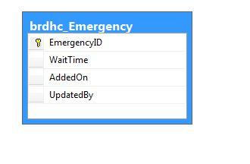

**The dataflow diagrams:**

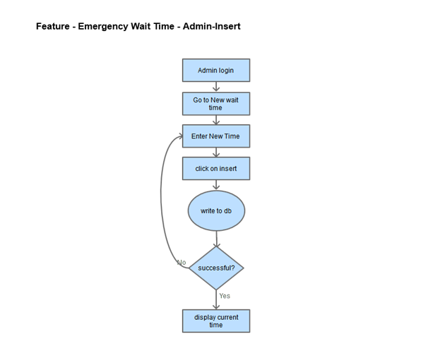

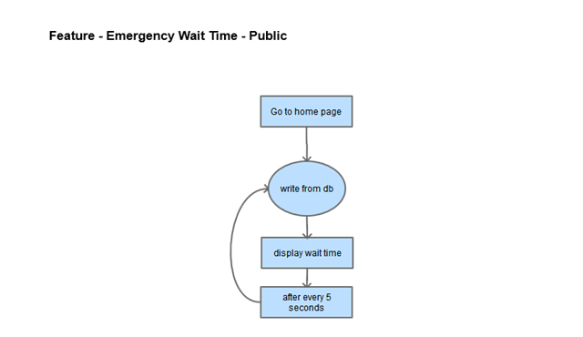

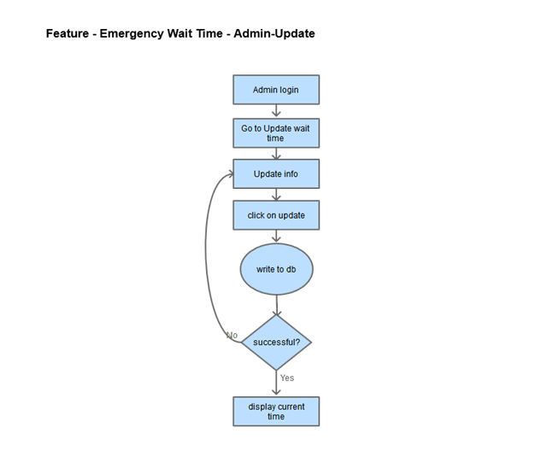

**Wireframes:**

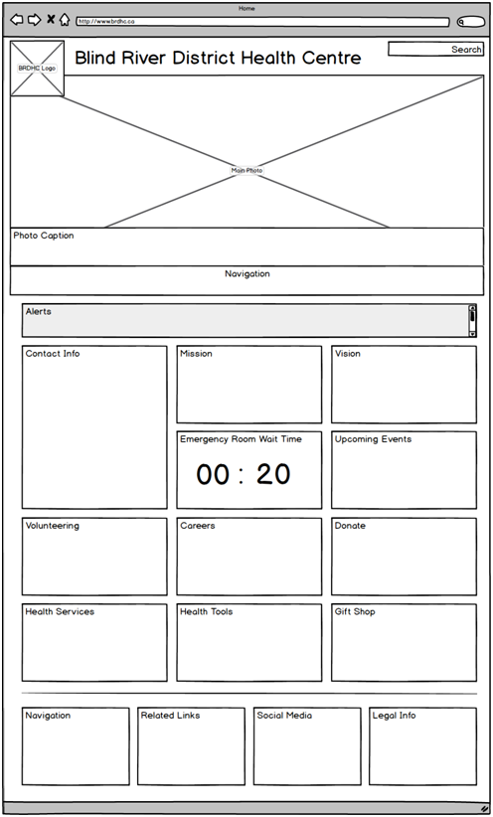

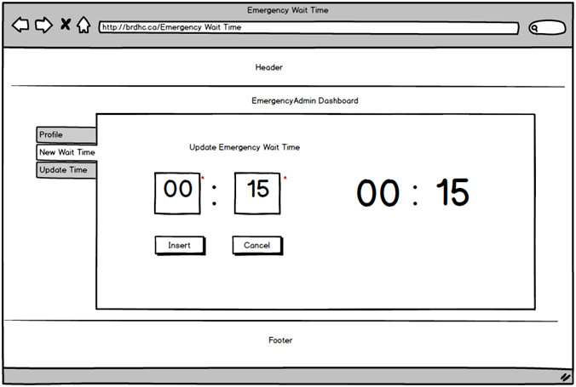

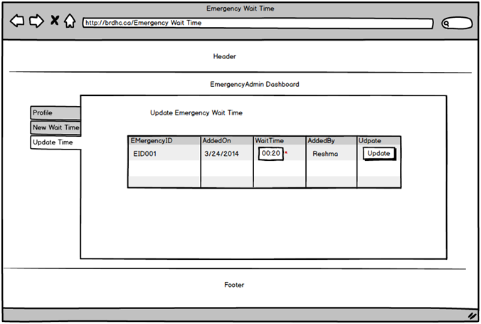

**Reshma: Feature: Pay Bills**

In case of any payments to be made by the patient, like medicines or treatment not covered by insurance, the patient can use this feature and make an online payment.

The admin must create an invoice for the patient. The patient can then verify the invoice and pay the charges. The admin can also update and delete an invoice.

Table: brdhc_Invoice

|  |  |
| --- | --- |
| InvoiceID | uniqueidentifier – Primary Key |
| PatientID | uniqueidentifier |
| CreatedOn | DateTime |
| Total Amount | Double |
| CreatedBy | Varchar |
| DueOn | Date |
| PaidOn | DateTime |
| Status | Text 100 characters |
| Reason | Text 255 characters |
| TransactionID | varchar |

Table: brdhc_InvoiceItems

|  |  |
| --- | --- |
| ItemId | Uniqueidentifier – PK |
| InvoiceID | Uniqueidentifier |
| ItemName | Text 100 characters |
| ItemCost | double |

When patients owe some money, brdhc Humber finance admin can create invoice with listing of all payable items and amount. Basically two tables are used for invoice and invoice items but aspnet_Users is also in the relation. brdhc_Invoice and brdhc_InvoiceItems tables use invoiceId column to make the relation where as userId column from aspnet_Users table and PatientId column from brdhc_Invoice table are used to make the relationship.

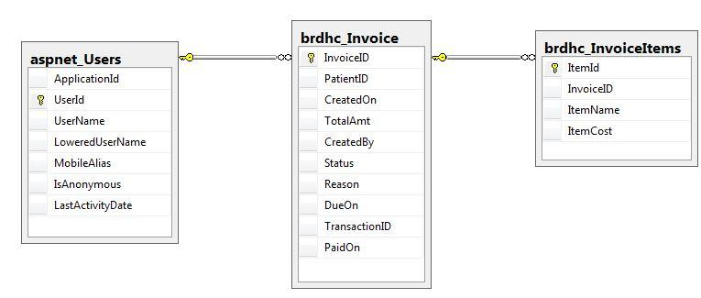

**The dataflow diagram:**

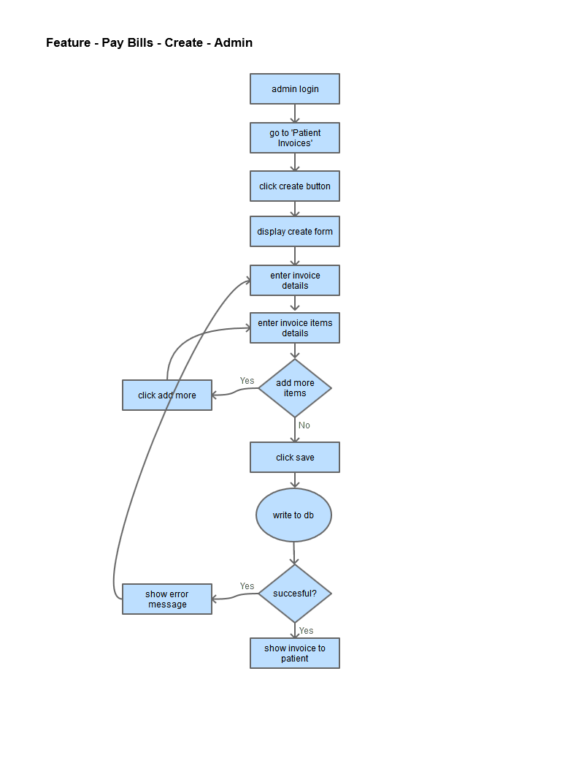

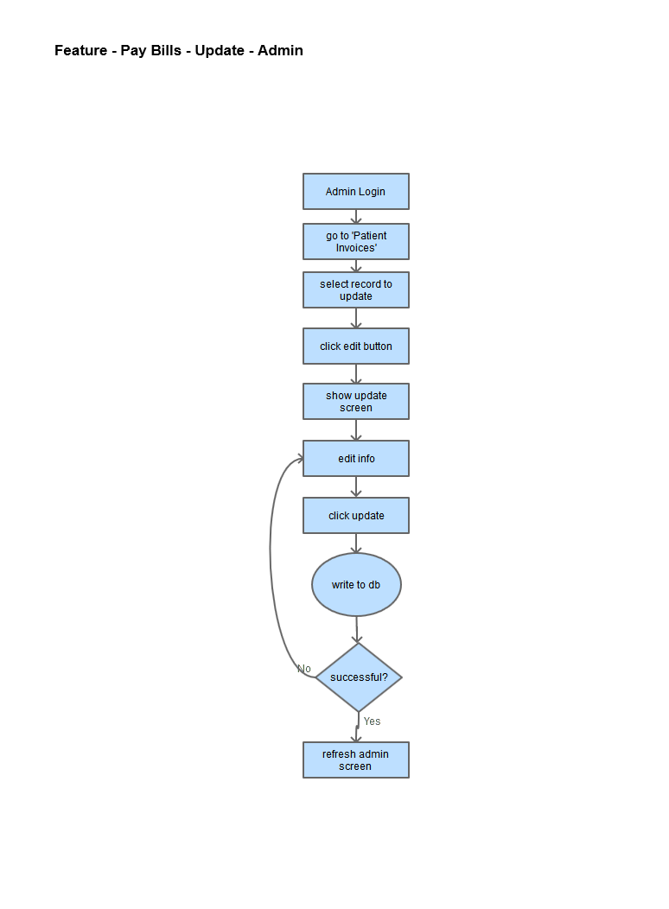

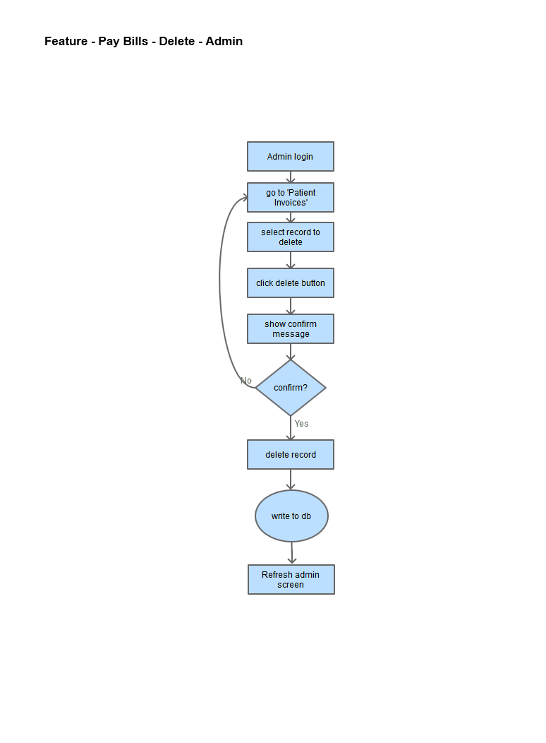

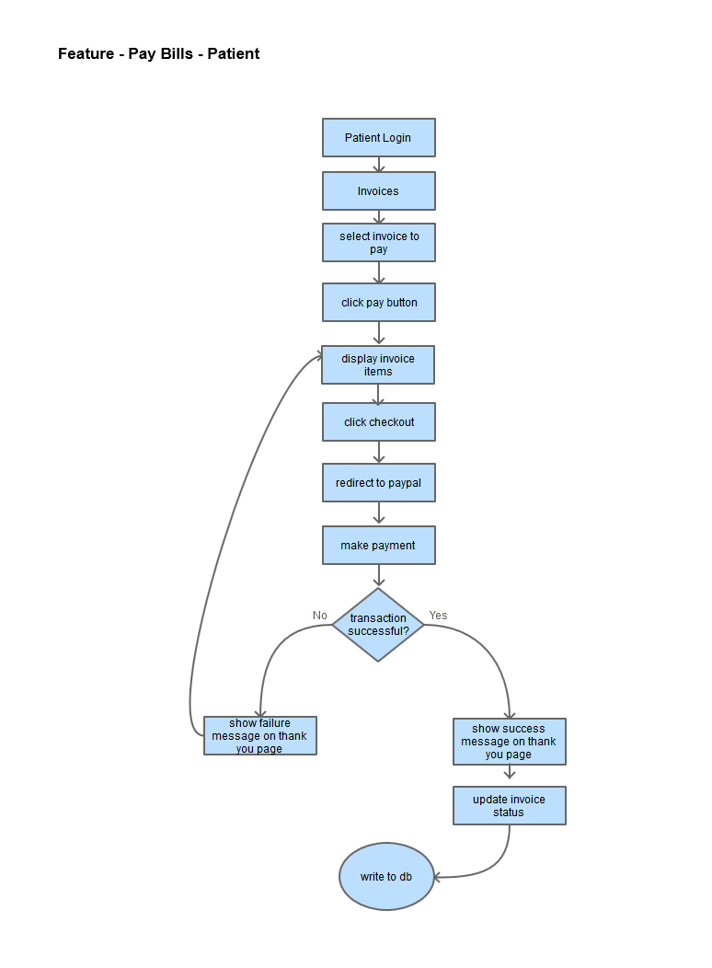

**Wireframes:**

create invoice

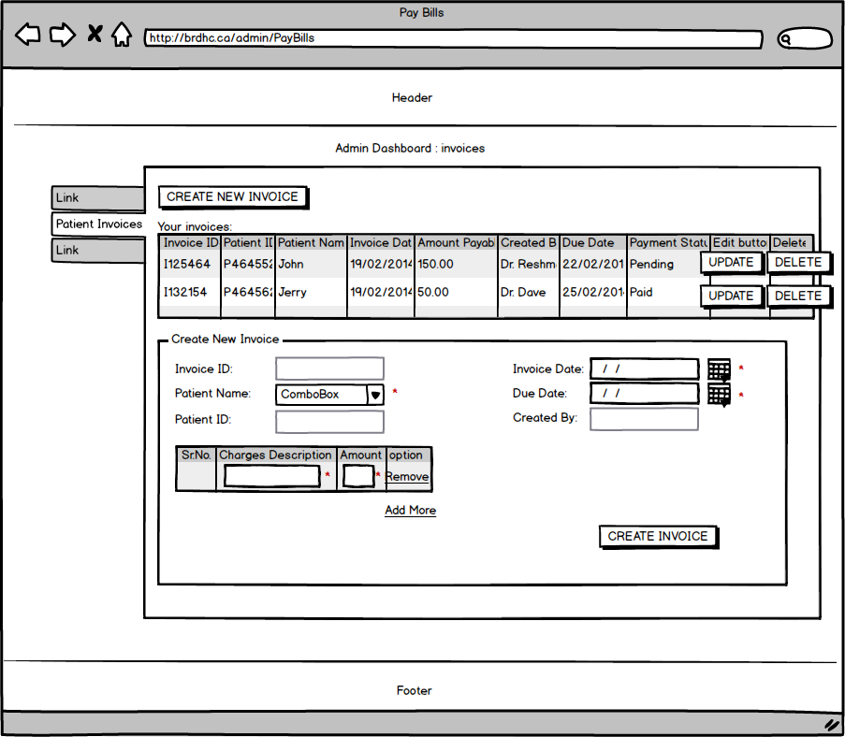

update invoice

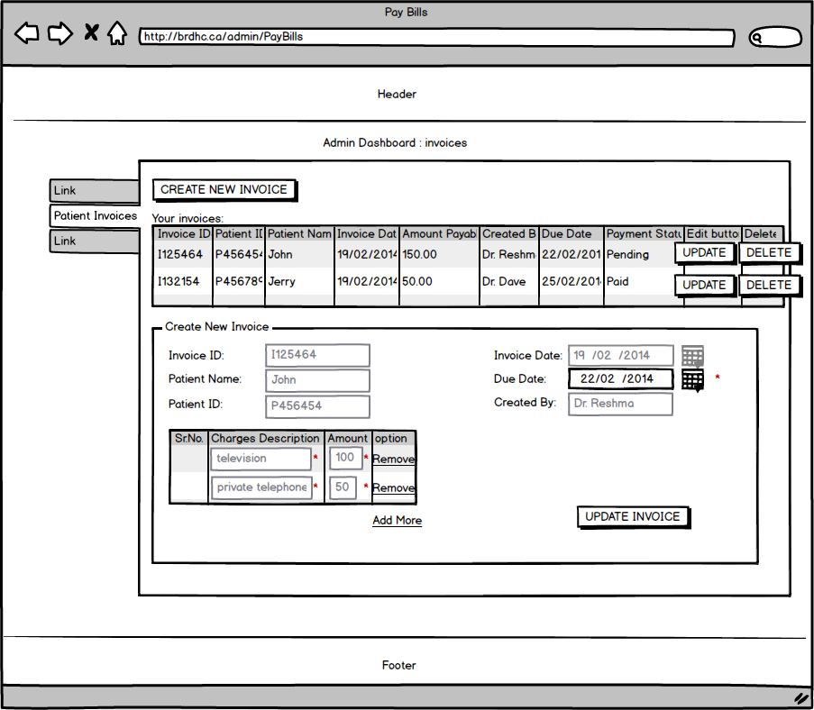

pay bill

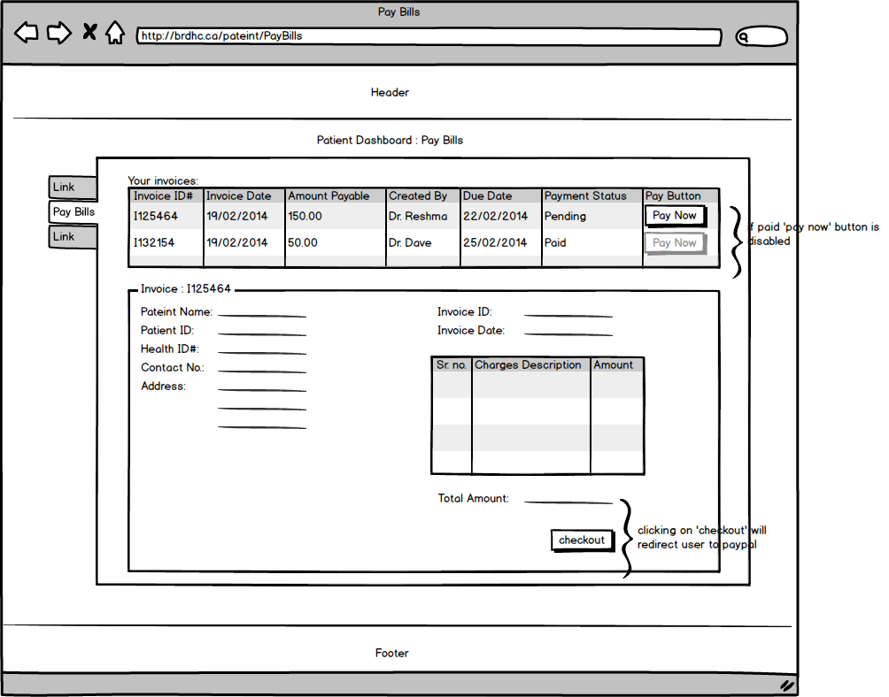

thank you page after payment

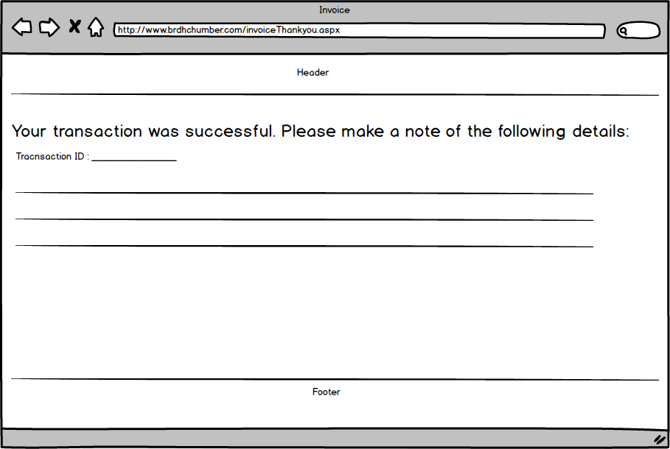

**Jagsir: Feature – Registration**

*Narrative Description*

The registration feature is for super admin user and doctors. Patients, doctors, and community members are required to be registered users in order to access their accounts. Registration page is not available to visitors. Only doctors of the hospital and super admin user have the privileges to register new users, however, doctors are allowed to register only patients but a super admin user can register user under any role. After login super admin user or doctor will see a link to registration page on dashboard. First of all registration page will display all the existing users sorted by their roles and names. This page will have another link to the registration form. Now at registration time doctors will not be asked to select the role because doctors are allowed to register only patients but super admin user must have to select a role before going forward. User names, emails, Identification, and Health Card Numbers are to be unique and if any of these already exists in the database, registration will be unsuccessful. Now if registration is successful, doctors or super admin user will again see the lists of all users. If there is need to change the information of any user, it can be done on the same registration page. All the doctor or super admin user have to do is to click on the name of the user and the information will be loaded into fields on registration form. Here information can be updated. Doctors can change the information of patients only. Super admin user can lock or delete any user on the system but doctors are able to only delete the patients.

All information is stored in various relational data tables in the database. For the registration following tables are used:

aspnet_Users

|  |  |
| --- | --- |
| User Id | Unique Identifier **(PK) (Auto Generated)** |
| Application Id | Unique Identifier **(FK)** |
| User Name | Text 256 characters |
| Mobile Alias | Text 16 characters |
| Is Anonymous | True / False |
| Last Activity Date | Date |

aspnet_UsersInRoles

|  |  |
| --- | --- |
| User Id | Unique Identifier **(FK)** |
| Role Id | Unique Identifier **(FK)** |

aspnet_Membership

|  |  |
| --- | --- |
| User Id | Unique Identifier **(FK)(PK)** |
| Application Id | Unique Identifier **(FK)** |
| Password | Text 128 characters |
| Password Format | Numeric |
| Password Salt | Text 128 characters |
| Mobile PIN | Text 16 characters |
| Email | Text 256 characters |
| Lowered Email | Text 256 characters |
| Password Question | Text 256 characters |
| Password Answer | Text 256 characters |
| Is Approved | True / False |
| Is Locked | True / False |
| Create Date | Date |
| Last Login Date | Date |
| Last Password Changed Date | Date |
| Last Lockout Date | Date |
| Failed Password Attempt Count | Numeric |
| Failed Password Attempt Window Start | Date |
| Failed Password Answer Attempt Count | Numeric |
| Failed Password Answer Attempt Window Start | Date |
| Comment | Text Max characters |

brdhc_UserBasicInfo

|  |  |
| --- | --- |
| User Basic Info Id | Unique Identifier **(PK)(Auto Generated)** |
| User Id | Unique Identifier **(FK)** |
| First Name | Text 50 characters |
| Last Name | Text 50 characters |
| Date of Birth | Date |
| Gender | Text 1 characters |
| Identification | Text 20 characters |
| Address | Text 100 characters |
| City ID | Unique Identifier **(FK)** |
| State Id | Unique Identifier **(FK)** |
| Postal Code | Text 7 characters |
| Phone | Text 15 characters |
| Fax | Text 15 characters |
| Family Doctors | Text 50 characters |
| Department | Text 50 characters |
| Join Date | Date |
| Speciality | Text 50 characters |
| Community Group Name | Text 100 characters |

All tables have primary-foreign key relations with userId but aspnet_Membership and aspnet_Users tables are related through ApplicationId column. Here is the relational diagram for registration tables.

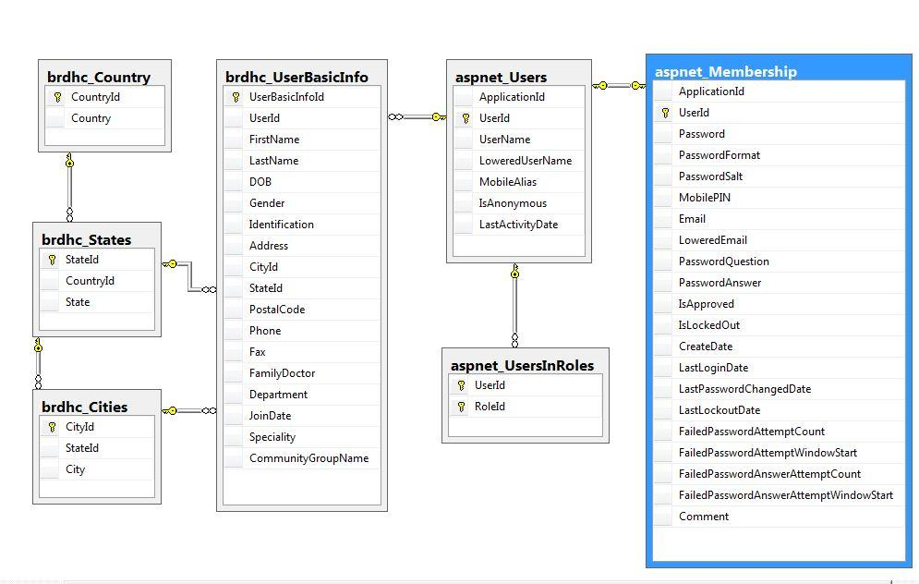

*The Dataflow Models*

Here is process of new registration in terms of data flow models

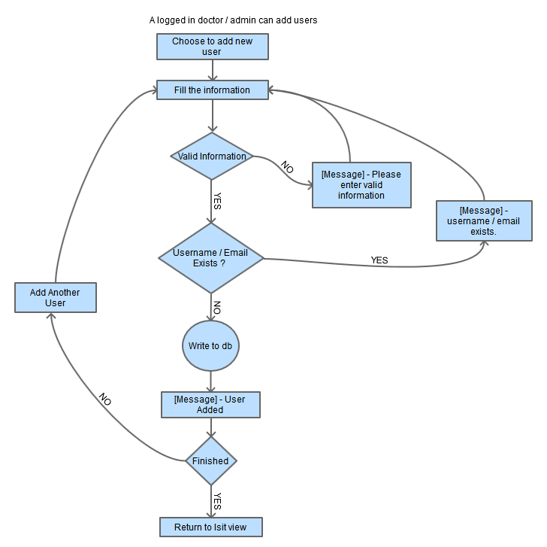

It is expected that admin or doctors are logged in. They provide the required information and if this information already exists in the database then user will be asked to re-enter new information or to quit. Once user is done with filling with information, a query will execute to save the information into the database. But if admin or doctor is registering patient then they will see another button on the form page which is a link to appointment page. Now if it is patient they might need to book an appointment for the patient and then they will click on this button which will redirect them to appointment booking form page.

Now if admin wants to edit the information of any existing user, then he will select the user from list and submit the form after changes. Here is data flow model to demonstrate the process of information change

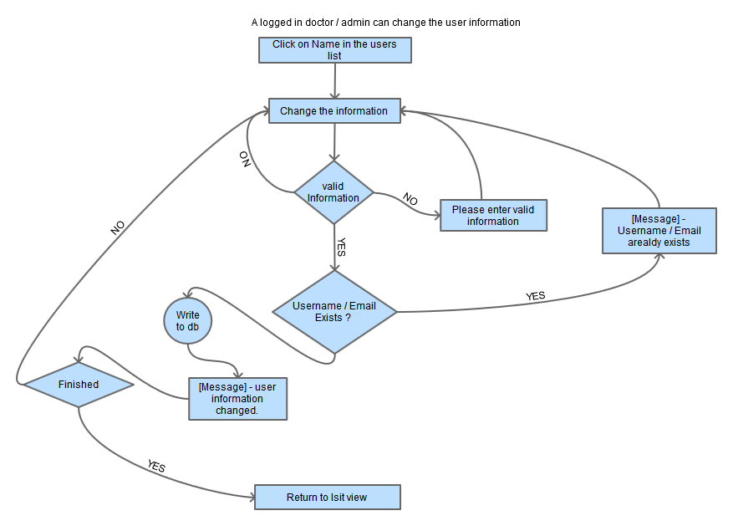

For security reasons, a user is allowed only five times to enter the wrong credentials while login. If user enters wrong password more than five times in a row, account will be locked and only administrative user can unlock the account. On the other hand, If Administrative user finds any other user trying to violate the information, admin can lock the account until clearance.

Following flow chart explains the process of deleting, locking, or unlocking of users by admin or doctors.

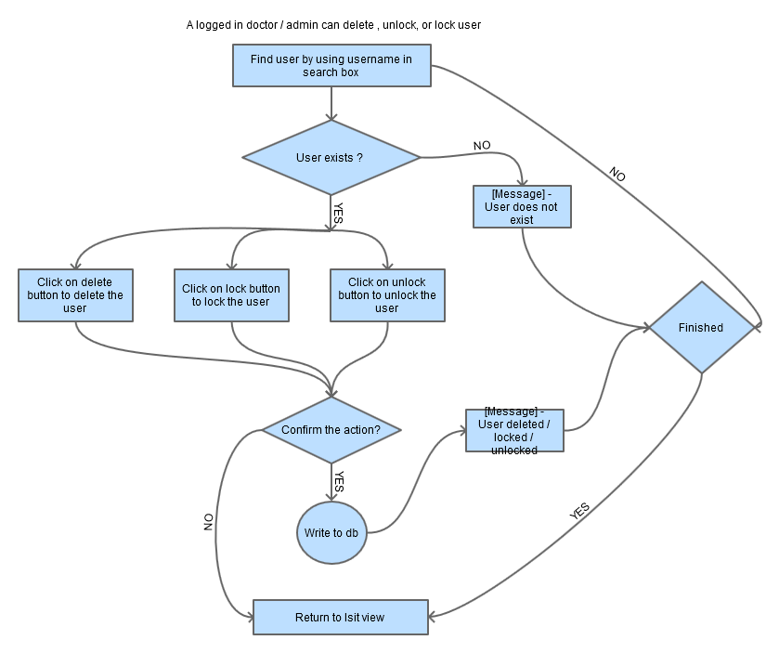

*Wireframes*

Here is the wireframe of adding new patient by super admin

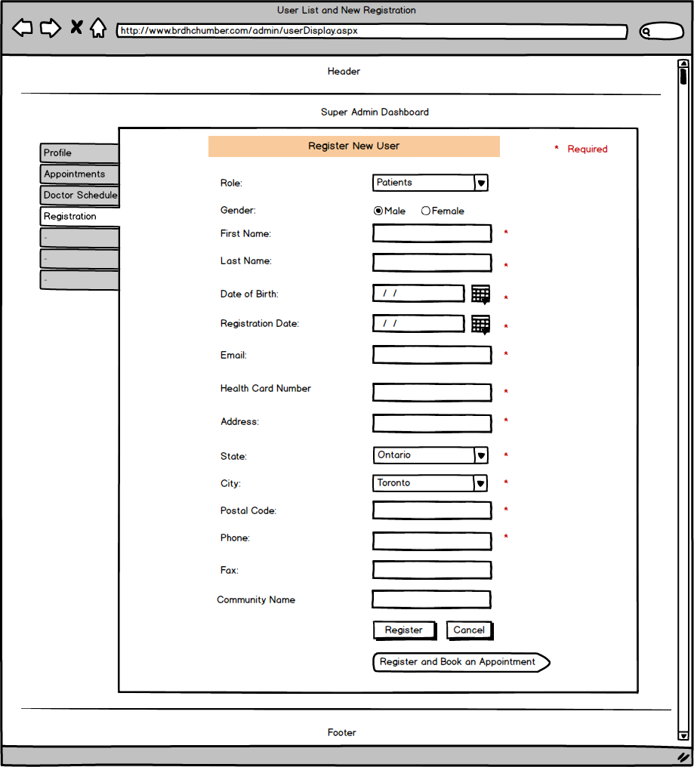

Here is the wireframe of adding new doctors by super admin

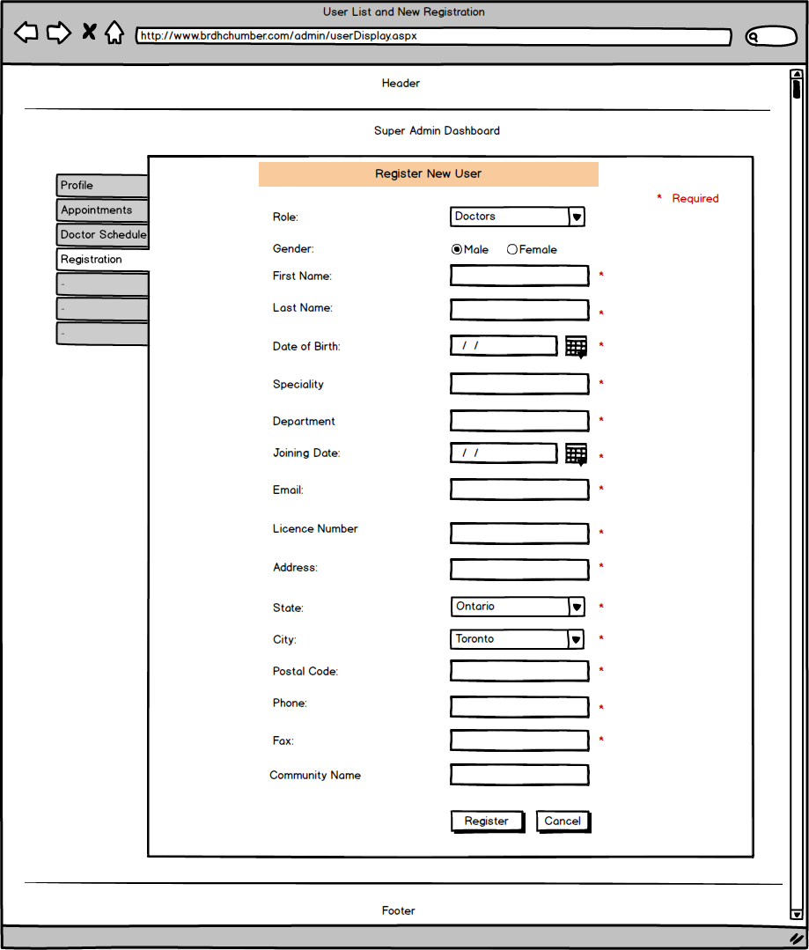

Here is the wireframe of adding new community members by super admin

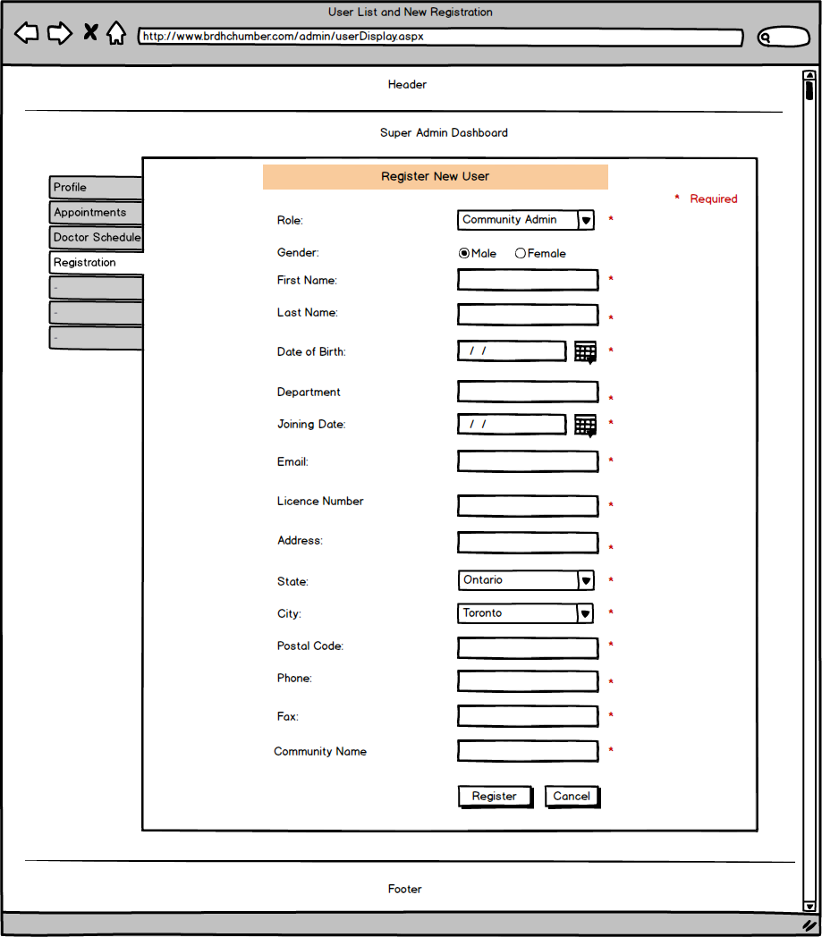

Here is the wireframe of adding new patient by Doctor

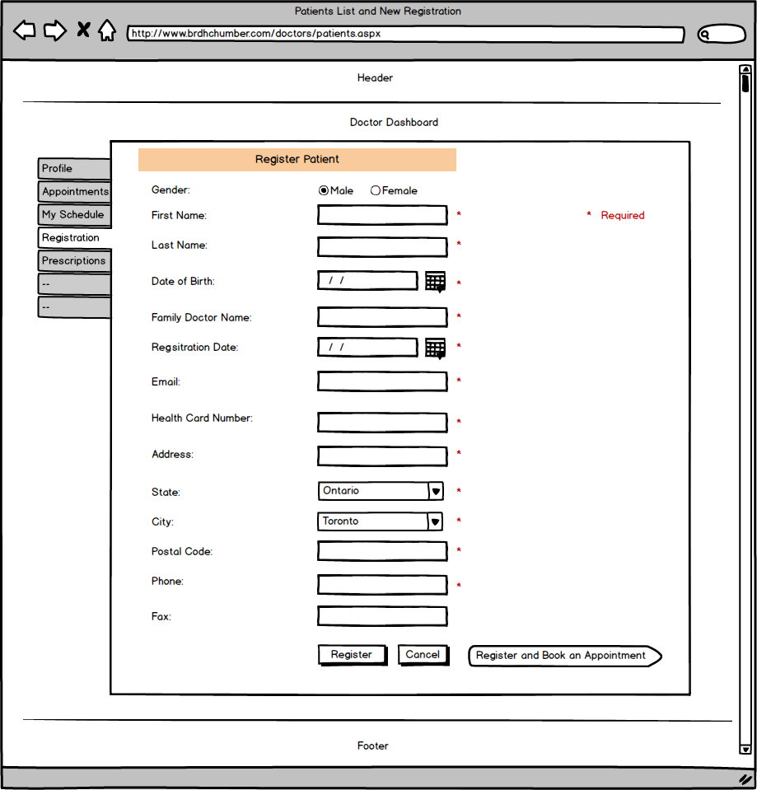

Here is the wireframe of all users list view to super admin account

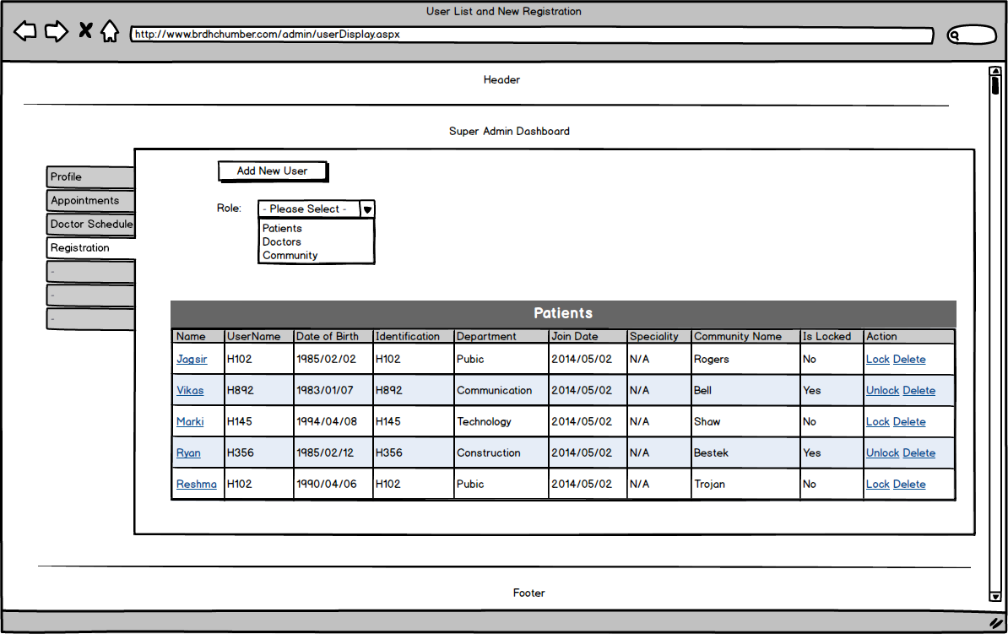

Here is the wireframe of patients listing for doctors account

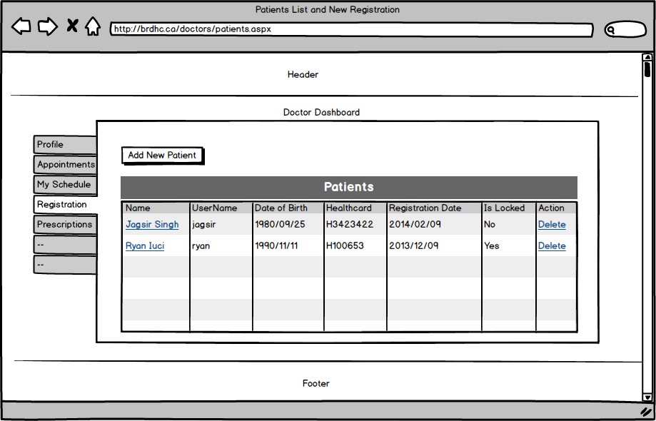

**Jagsir: Feature - Book an Appointment**

*Narrative Description*

This feature is for only admin and doctors. To book an appointment, patient must be registered first. So if patient is not registered, user cannot book an appointment. Admin and Doctors need to login into their accounts for this functionality. After log in, they will see link to appointments page. If it is doctors who logs in, there will all the appointments related to logged-in user but if it is super admin user, then he/she may need to search the appointments by using search box with patient name.

Already booked appointments can be canceled or rescheduled from this page.

To book new appointment user would need to click on New Appointment button. This will display the form. Here users need patient health card number to find the details like name of the patient and if patient doesn’t exist in database, it should be.

For the date and time of the appointment, only available dates and time will be visible on the form for the users to select. Already booked time will be removed from the dropdown list. Weekend days are not selectable for the appointments which means appointments can be made for weekdays only.

Once the appointment is made, patients will get an email notification. Appointments made by super admin or doctors do not need to be approved because approval status will be “approved” but if patient request for the appointment it will need to be approved by doctors and initially its approval status will be “pending”. When patient sends request for the appointment, doctors will check who has requested and the time will be allotted to first request. Others will get notifications over email about rejection. Upon approval, the approval status of appointment request will change from pending to approved and whereas upon rejection approval status will change from pending to rejected.

CreatedOnDate field will contain date of request made for appointment.

All the information will be saved into database table brdhc_PatientAppointments but other tables are also in use because of the primary-foreign key relationship. Database Relational Diagram looks like below.

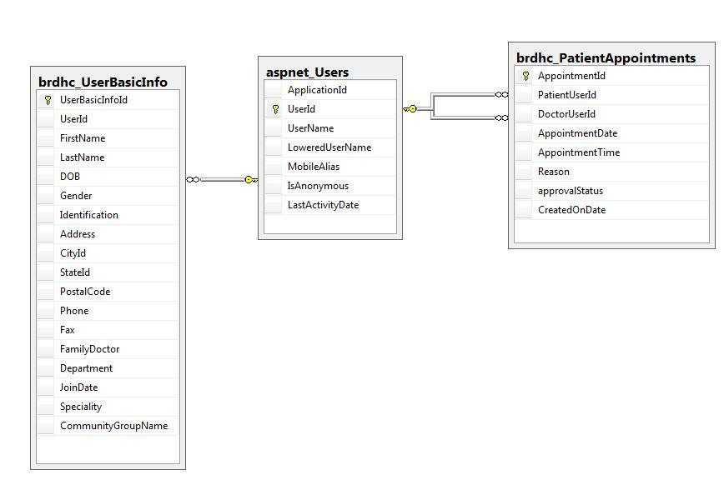

Following is the table schema

brdhc_PatientAppointments

|  |  |
| --- | --- |
| Appointment Id | Numeric **(PK) (Auto Generated)** |
| Patient User Id | Unique Identifier **(FK)** |
| Doctor User Id | Unique Identifier **(FK)** |
| Appointment Date | Date |
| Appointment Time | Time |
| Reason | Text MAX character |
| ApprovalStatus | Text 50 characters |
| Created On Date | Date |

*The Dataflow Models*

Here is the data flow model to present the process of booking an appointment

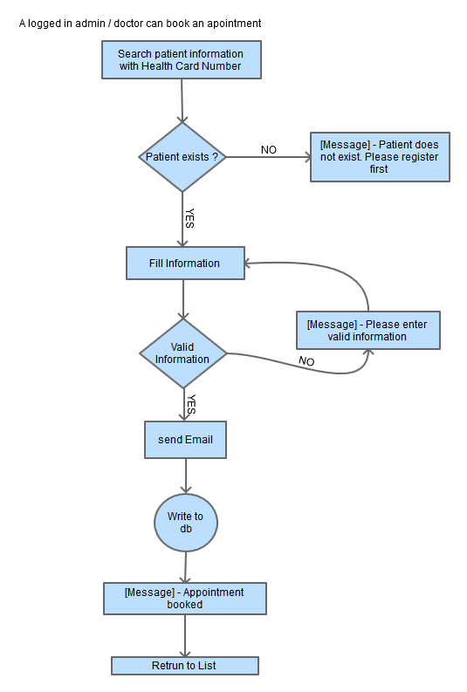

In case patient is not willing to come on the selected date, doctors or admin can reschedule the appointment. All they have to do is to select the appointment from listing and same form will display with appointment information in fields. New time will be allocated to the patient and previous date and time will become available to others. Here is the flow chart to explain the edit process steps.

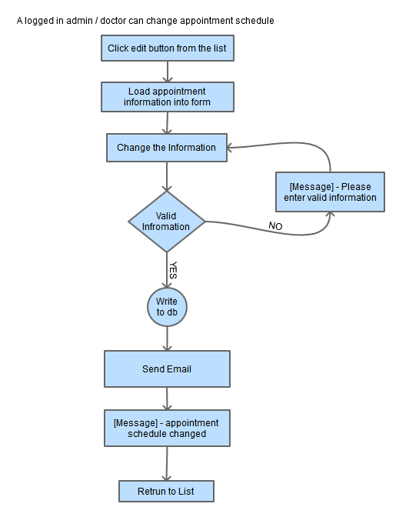

Patient can make request to cancel the appointment and following is the data flow model to define the process of appointment cancelation.

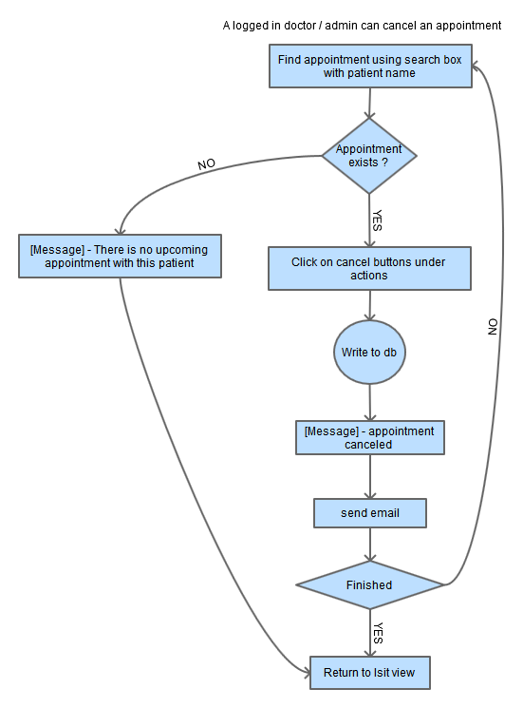

*Wireframes*

Here is the wireframe for booking an appointment by admin for the patients

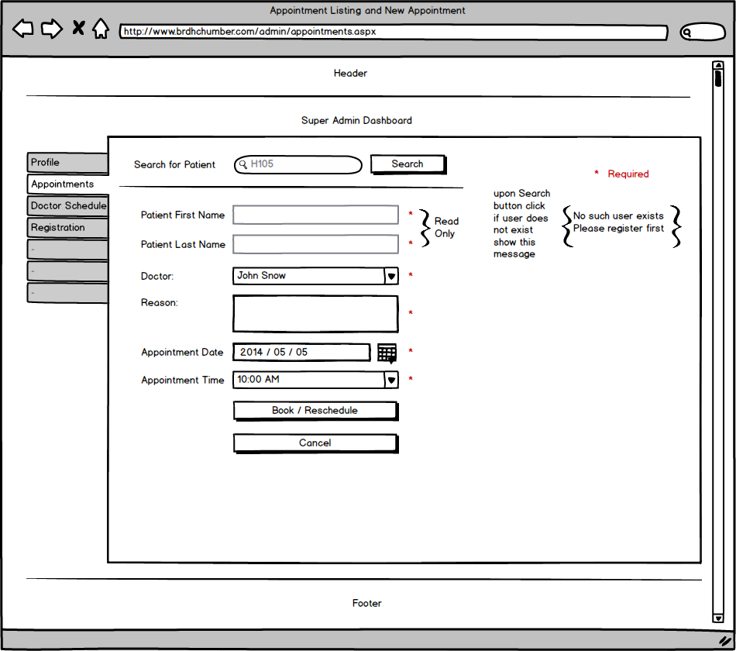

The interface to book an appointment will be similar for the doctors. The only difference is there is no drop down to select the doctor’s name because doctor can not book an appointment for other doctors. Here is the wireframe for doctors to book an appointment.

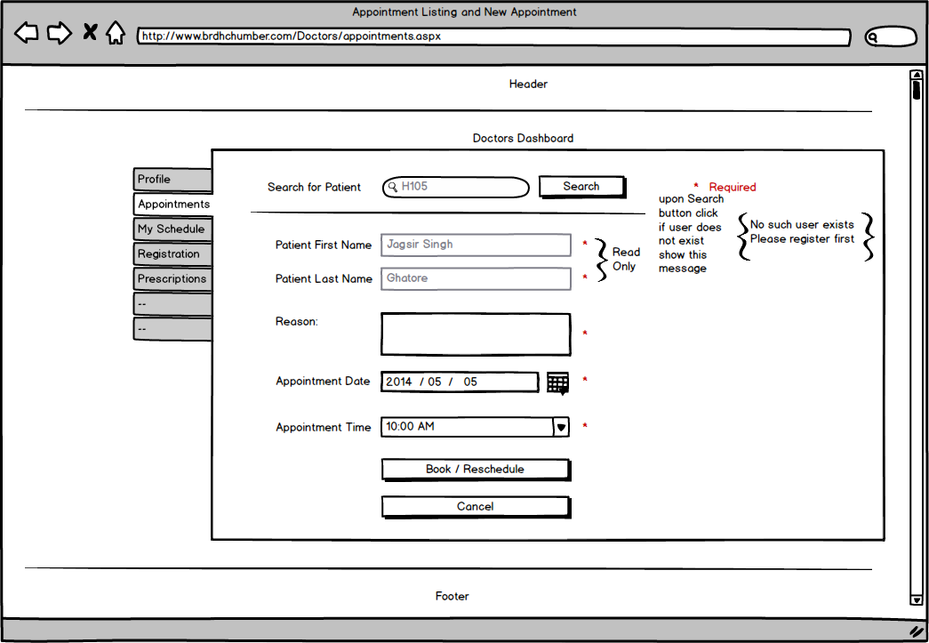

List view of all Appointments in admin’s account will be as in the following wireframe

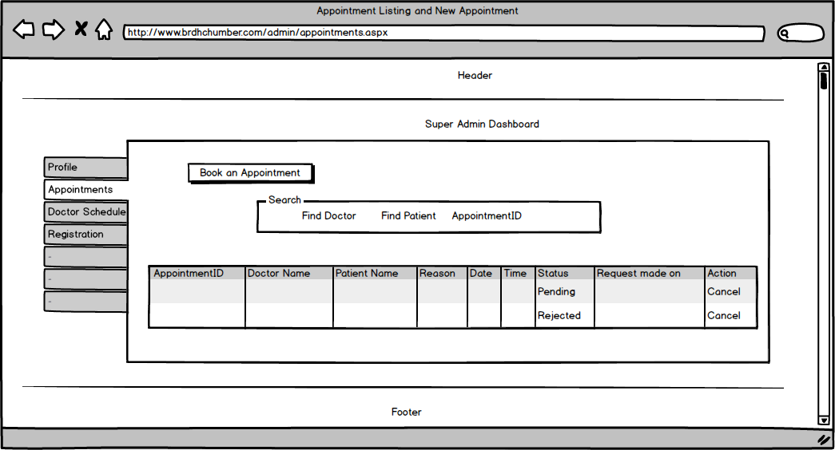

**Jagsir: Feature – Alerts**

*Narrative Description*

Alerts are the notifications that hospital staff wants to tell everybody. For example if there is any virus spreading possibility or hospital is going to provide vaccination then it can be done from the website by displaying that information in the form of Alerts. When users visit website, they will know it. Moreover, if user is registered on hospital website, he/she will get notifications of these alerts in the emails. But users can unsubscribe themselves from these notifications. When they click on unsubscribe me link passed in email, their email will be removed from database so next time they will not get any email regarding these alerts.

Alerts have admin interface and public interface. A short message of the latest alert is shown on the screen and when visitor click on read more link button a separate page with complete information opens. Here users can email these alerts to anyone.

Admin user can add, update, delete, publish, and delete. To update, publish and delete same form is used by admin. All the information is stored in database. To publish the alert on home page, admin will need to click publish button.

The following diagram show the relationship among tables used for this feature

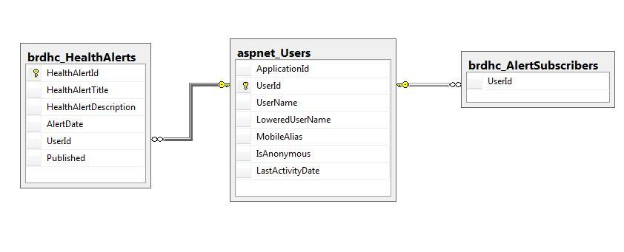

The table schema used for alerts is like below:

brdhc_HealthAlerts

|  |  |
| --- | --- |
| Health Alert Id | Unique Identifier **(PK) (Auto Generated)** |
| Health Alert Title | Text 100 characters |
| Health Alert Description | Text MAX characters |
| Alert Date | Date |
| User Id | Unique Identifier |
| Published | True / False |

brdhc_AlertSubscribers

|  |  |
| --- | --- |
| User Id | Unique Identifier **(FK)** |

*The Dataflow Model*

After login into personal account admin user will see a link for alerts in the dashboard. Upon clicking this link, user will see alerts listing page and this page also contains the link to form where user can add new alerts. At this form user will provide the required information and all the information will be saved into database table. Following data flow model explains the process of adding new alerts in the database

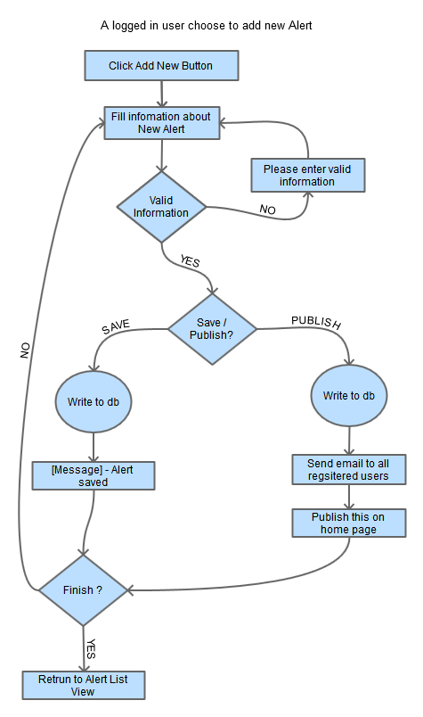

And admin can edit the information of alert like alert title, message. Once the user select the alert from list to update and click on edit button same form will display that is used to add new alerts. Following is the flow model for information updating.

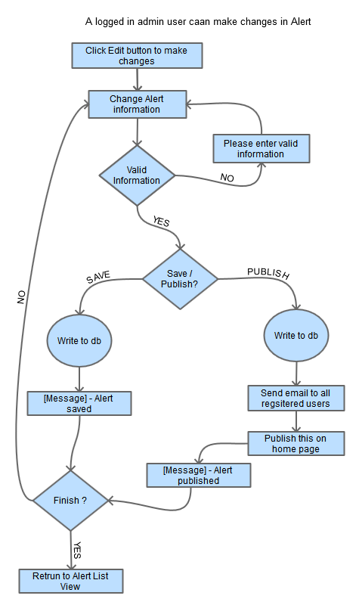

Data flow model to delete the Alert is given below:

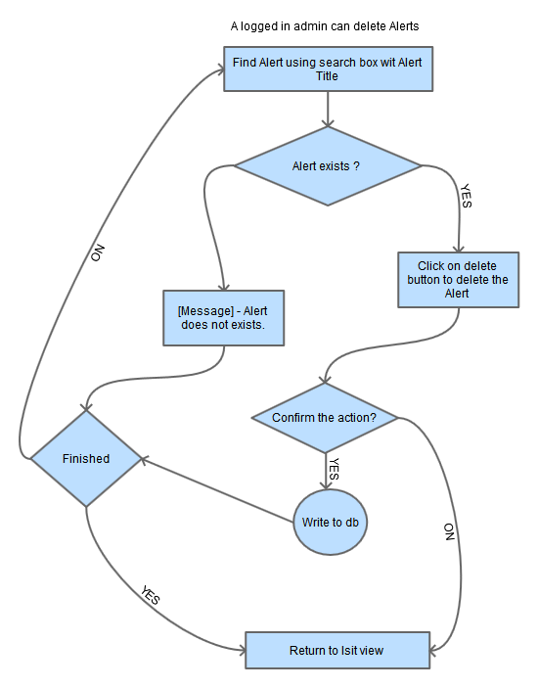

*Wireframes*

Interface to add new alerts or to update alerts looks like below:

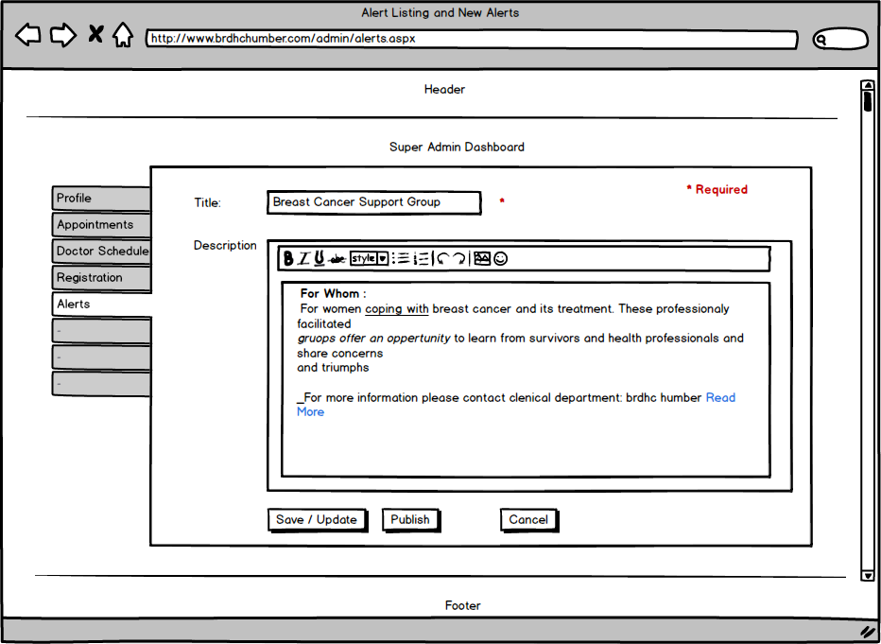

Following is the wireframe to display all the alerts

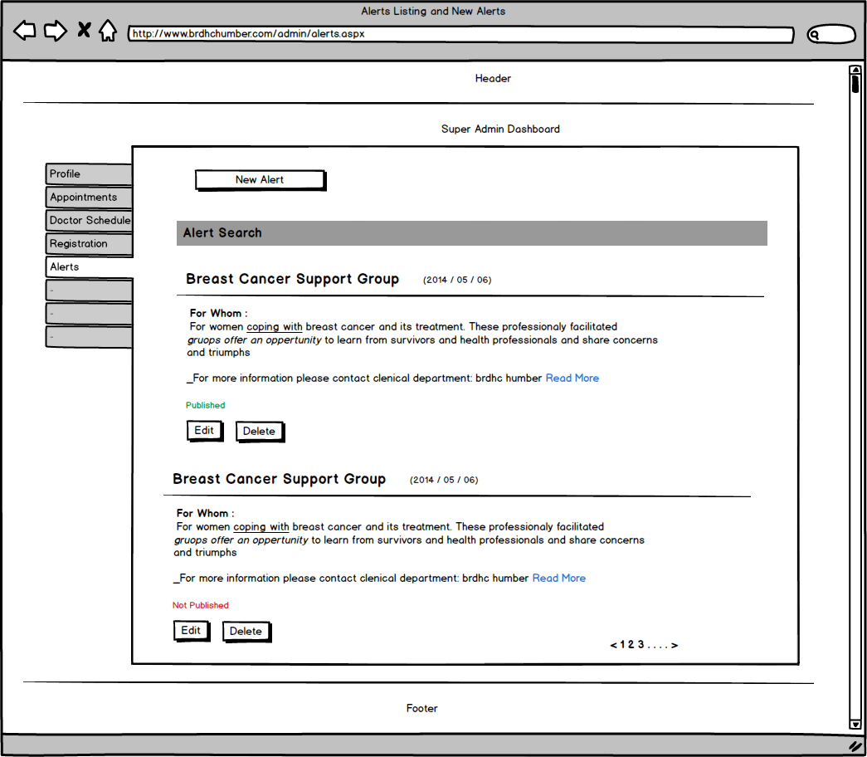

And here is the wireframe that explains how the alerts page will look like when a visitor tries to see alert in detail. 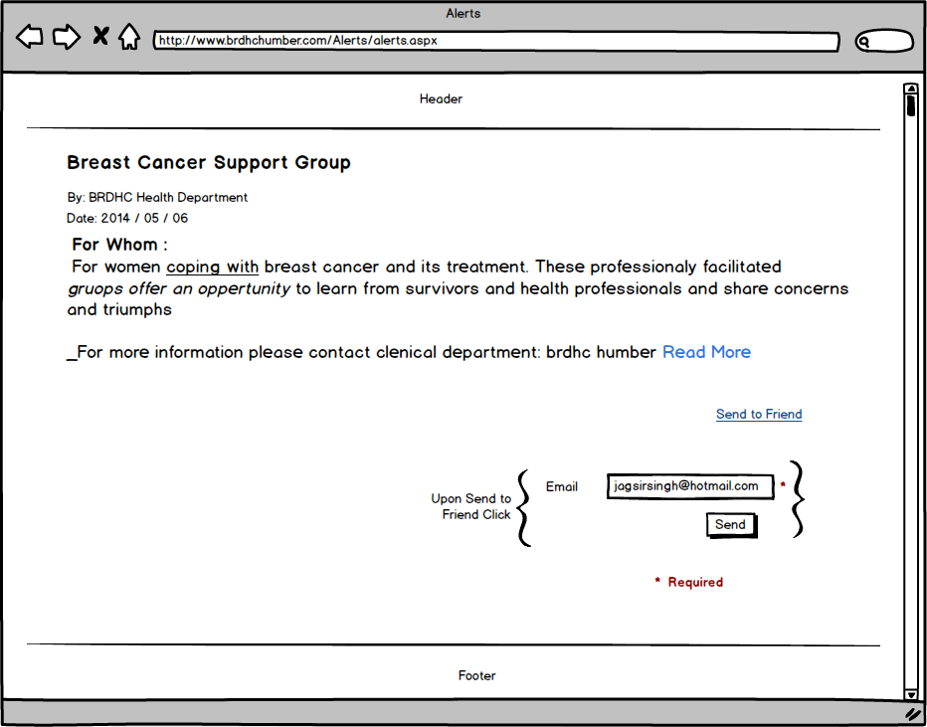

**Jagsir: Feature – Prescriptions**

*Narrative Description*

Prescriptions are related to appointments. When patients meet doctors and doctors write prescriptions. The information of prescription is stored in system by doctors. This information contains appointment id, patient information, date, medicine details, repeat, medicine timings, and quantity to take at a time.

When prescription is saved in database, patients can view prescription details in their account; moreover, they can print schedule for medicines. Only doctors can add and delete prescriptions. But once the prescription is added, nobody can make changes. To make changes doctors will have to delete the prescription first and then will have to add new one.

Structure of tables is below:

Here is the diagram that shows the relationship between tables.

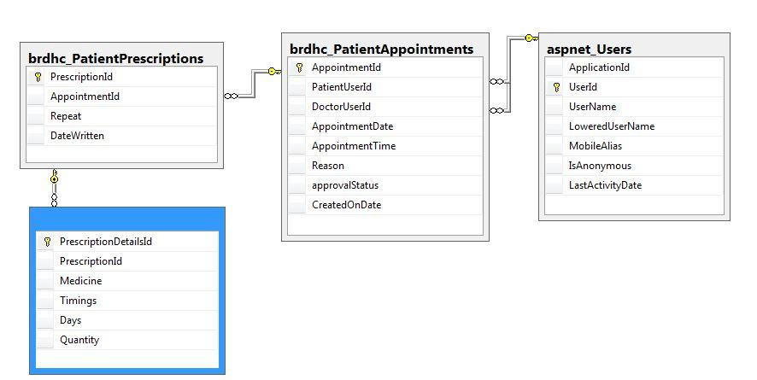

brdhc_PatientPrescriptions

|  |  |
| --- | --- |
| Prescription Id | Numeric **(PK) Auto Generated** |
| Appointment Id | Numeric **(FK)** |
| Repeat | Numeric |
| Prescription Date | Date |

brdhc_PrescriptionsDetails

|  |  |
| --- | --- |
| Prescription Id | Numeric **(FK)** |
| Medicine | Text 100 characters |
| Timings | Text 100 characters |
| Days | Numeric |
| Quantity | Numeric |

*The Dataflow Models*

To add prescriptions, doctors needs to be logged in. Doctor will see prescriptions link on dashboard. First it will display list of all the prescriptions. Doctors will need to click add new prescription button that in further will open a new form for prescription information. Here once doctor is done with filling all the information and click submit button, information will be saved into database.

Following data flow explains the process of adding new prescription into database.

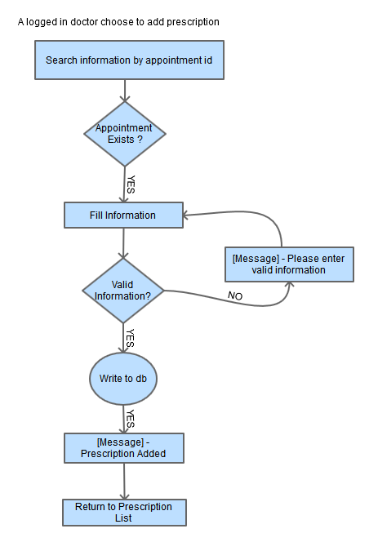

*Wireframes*

When doctors view list of prescriptions, it will look like below

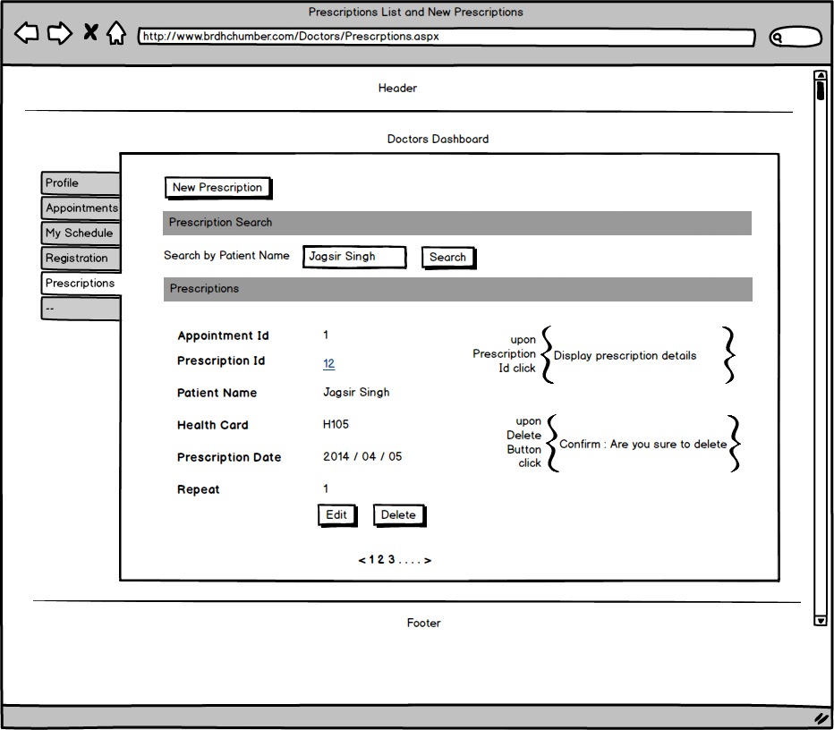

Here is the wireframe for prescription in patients account

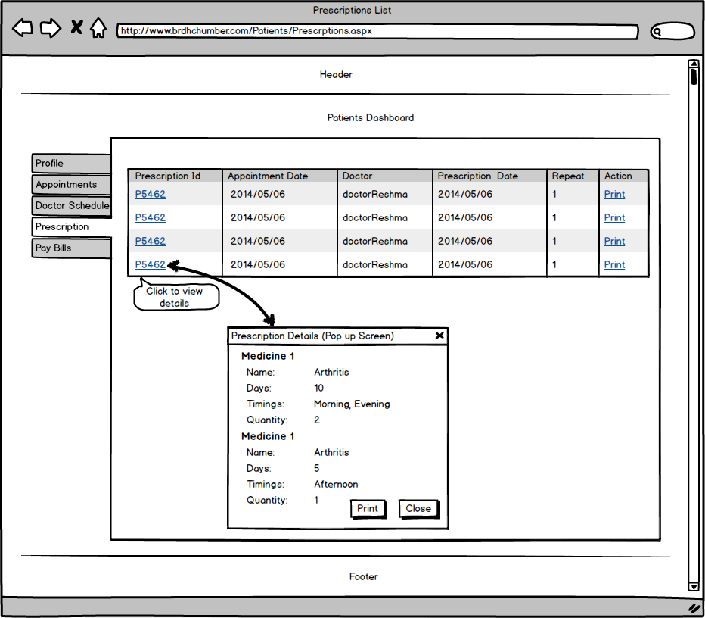

And here is the wireframe to add new prescription by doctors

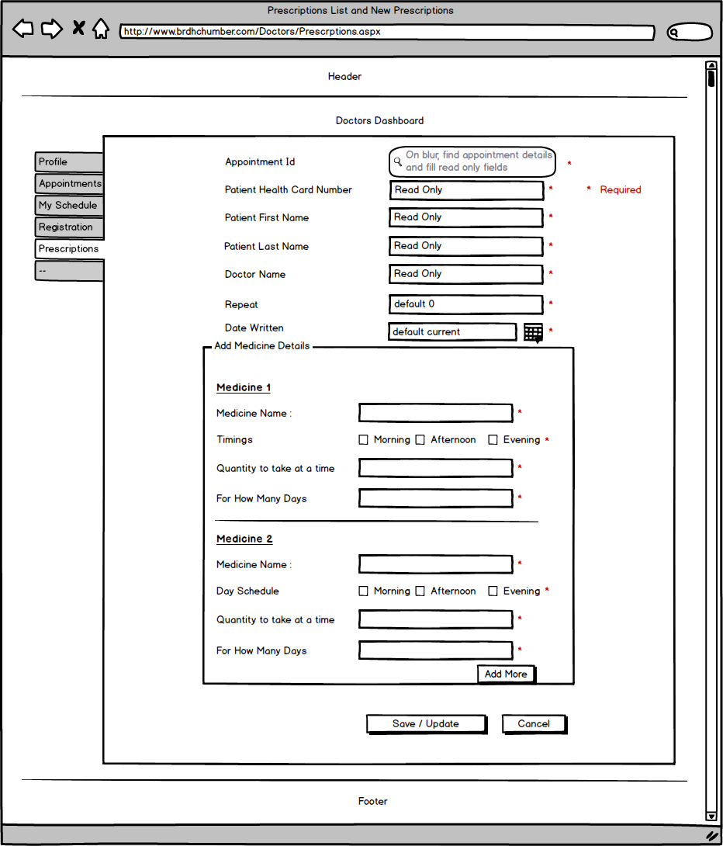

**Marki: Feature 1 - Volunteer Opportunities**

*Narrative description*

The ‘Volunteer Opportunities’ feature is an efficient way for the hospital to post volunteer opportunities and receive volunteer applications. Visitors to the website will see a special section dedicated to ‘Volunteer Opportunities’ on the homepage. By clicking on a link in this section or the link in the navigation menu under ‘Support Us’ the visitor will be taken to the ‘Volunteer Opportunities’ page. Your Volunteer Coordinator will be able to easily update opportunities, as well as track, organize and process applications. From the perspective of a potential volunteer the simplicity of this service will decrease the amount of steps they would need to take to apply.

The ‘Volunteer Opportunities’ feature will have an administrative page that will allow the Volunteer Coordinator to keep track of applications and post new opportunities.

The databases will look like this:

Available opportunities:

|  |  |
| --- | --- |
| Opportunity ID | Unique Identifier (PK) |
| Opportunity Title | Text up to 100 characters |
| Department | Text up to 100 characters |
| Skills Experience | Text up to 400 characters |
| Benefits Recognition | Text up to 400 characters |
| Other Requirements | Text up to 100 characters |
| Time Commitment | Text up to 40 characters |
| Date and Time | Text up to 40 characters |
| Contact Person | Text up to 40 characters |

Application form:

|  |  |
| --- | --- |
| Submission ID | Unique Identifier (PK) |
| Opportunity ID | Unique Identifier (FK) |
| First Name | Text up to 40 characters |
| Last Name | Text up to 40 characters |
| Address | Text up to 100 characters |
| Phone | Text up to 12 characters |
| Email | Text up to 40 characters |
| Date of Birth | Date |
| Occupation | Text up to 40 characters |
| Previous Experience | Text up to 400 characters |
| Why BRDHC | Text up to 100 characters |
| Commitment Length | Text up to 10 characters |
| Day | Text up to 10 characters |
| Start Time | Text up to 10 characters |
| End Time | Text up to 10 characters |
| Reviewed | Yes or No |

*Volunteer Opportunities*

brdhc_volunteerOpp and brdhc_volunteerApp database tables do not have any relationship between them. Here is the database diagram that displays the fields under these tables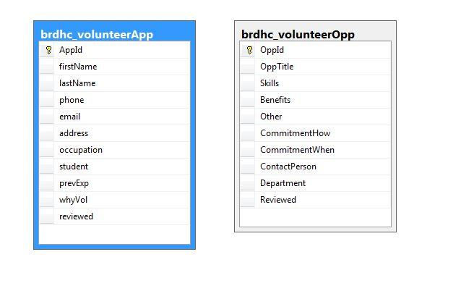

*Dataflow Models*

Here is how the “Apply to Volunteer at BRDHC” dataflow model would look:

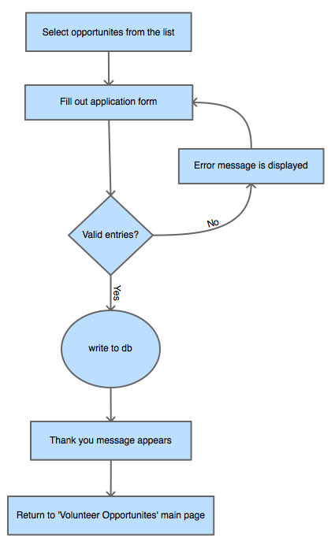

Here is how an administrator would add an opportunity:

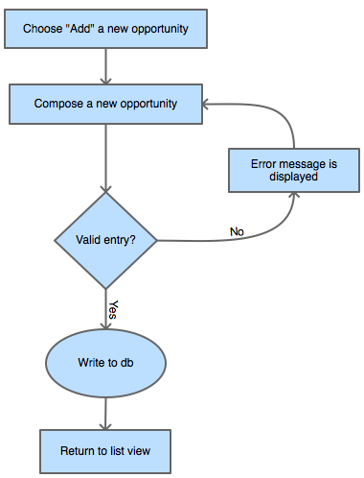

Here is how an administrator would edit an opportunity:

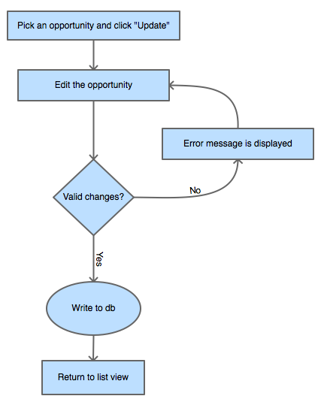

Here is how an administrator would delete an opportunity:

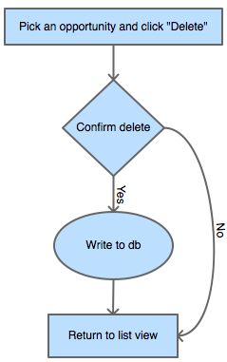

Here is how an administrator would review a submission:

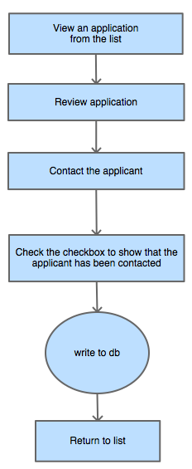

*Wireframes*

Here is how the “Apply to Volunteer at BRDHC” wireframe would look:

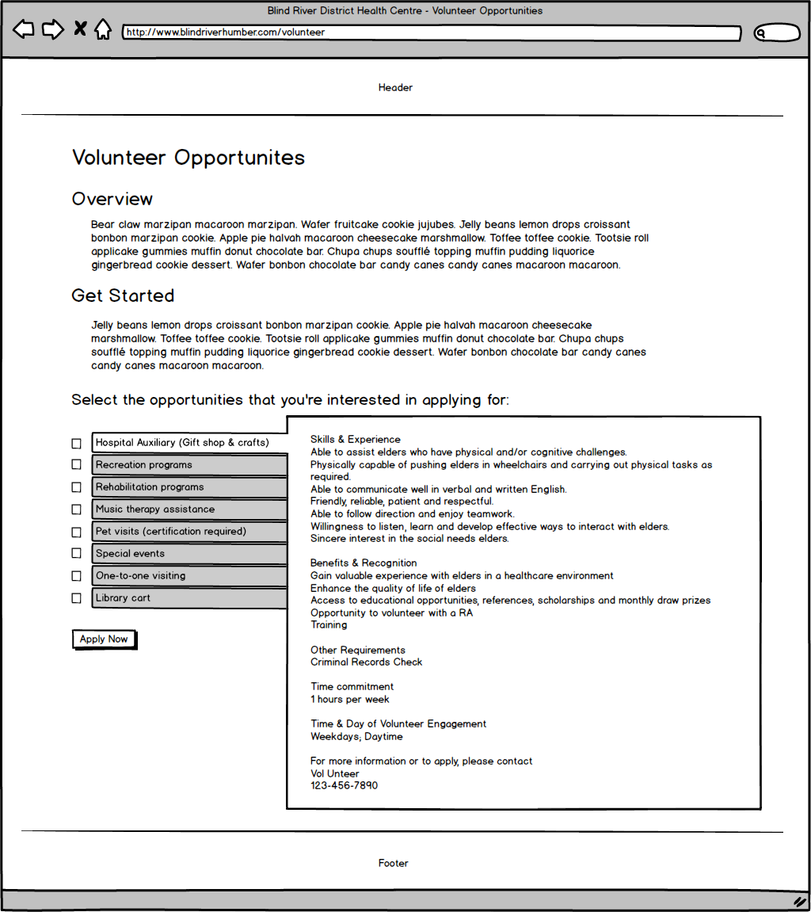

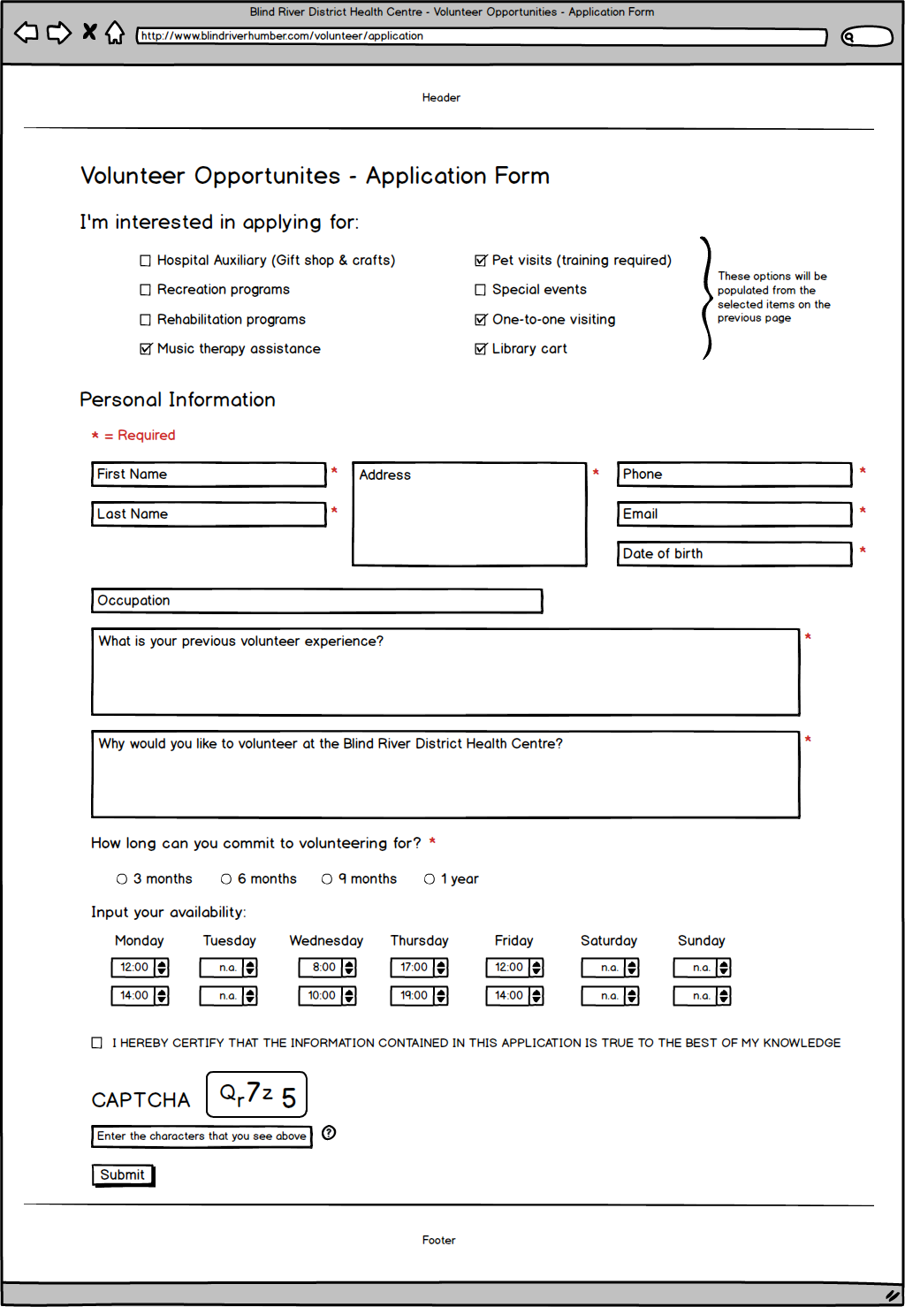

Here is how an administrator would post a submission:

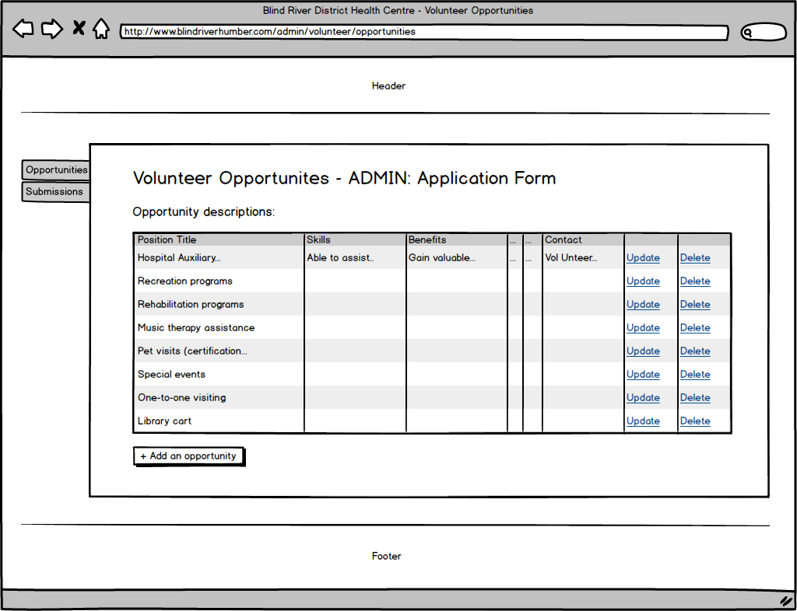

Here is how an administrator would process an application:

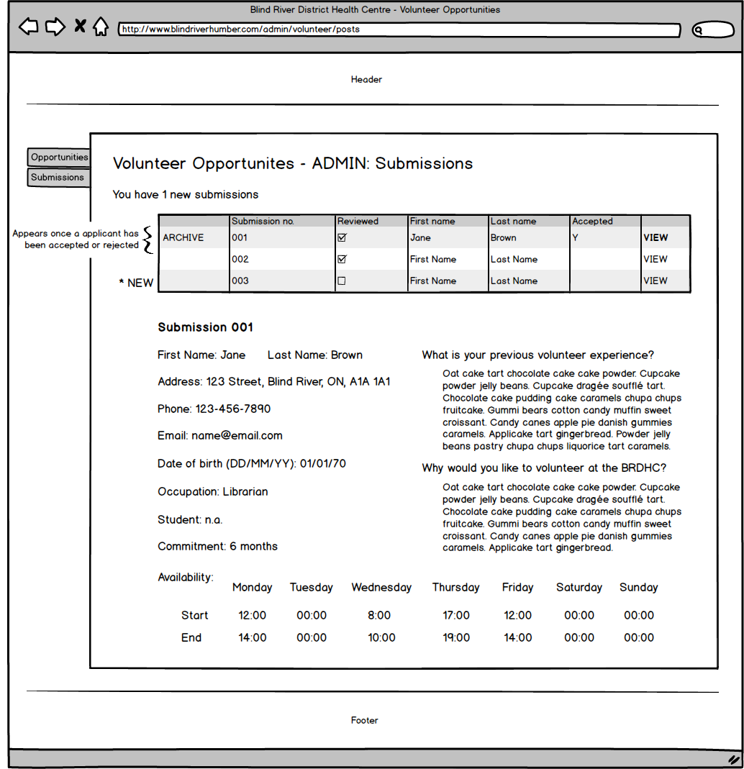

**Marki: Feature 2 - Gift Shop**

*Narrative description*

The ‘Gift Shop’ feature includes two sub-features: a free service, ‘Send a handwritten card to a loved one’ and a paid service, ‘Send flowers to a loved one’. Visitors to the website will see a special section dedicated to the gift shop on the homepage. By clicking on a link in this section or by clicking the link in the navigation menu under ‘Patients & Visitors’ it will take them to the gift shop page. This service allows friends and family to express their love and sympathy in a special way if they cannot be there in person. With the generous support of the hospital auxiliary volunteers, patients and their loved ones will feel the extra effort the hospital provides to help them feel loved and supported.

The ‘Gift Shop’ feature will have an administrative page that will allow the gift shop volunteers to keep track of the orders. The orders will fall under two categories: ‘Send a card’ or ‘Send flowers’. The volunteer will be able to keep track of which orders have been completed, and if the sender has been notified upon delivery. The volunteer will be able to archive previous orders once they have been fulfilled.

The databases will look like this:

Sending cards and flowers:

|  |  |
| --- | --- |
| Card_Id | Unique Identifier (PK) |
| Sender’s name | Text up to 40 characters |
| Sender’s email | Text up to 40 characters |
| Patient name | Text up to 40 characters |
| Patient room number | Text 4 characters |
| To | Text up to 40 characters |
| From | Text up to 40 characters |
| Message | Text up to 400 characters |

|  |  |
| --- | --- |
| Bouquet number | Numeric |
| Bouquet price | Numeric, decimal |
| Bouquet image | Text up to 100 characters |
| Payment total | Numeric, decimal |
| Date | Date |
| Written | True or False |
| Delivered | True or False |
| Sender notified | True or False |
| Archived | True or False |

Billing and Payment Information will be stored by a third party (PayPal)

*Gift Shop*

brdhc_GiftshopStore is used by Admin users to display all the stuff that is available for users to buy and gift. Basically each record is an item with Id, Name, Picture, Price. Another table brdhc_GiftShopSendCard is used to send the personal greetings in the form of written messages. When public users fill the form to send the greetings, all the information is stored in this table. Here is the database diagram that shows the fields under these tables.

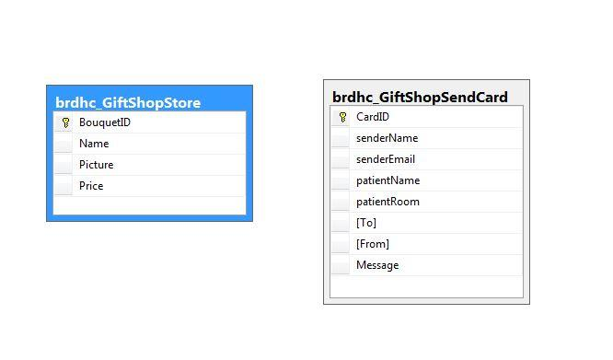

*Dataflow Models*

Here is how the “Send a card to a loved one” dataflow model would look:

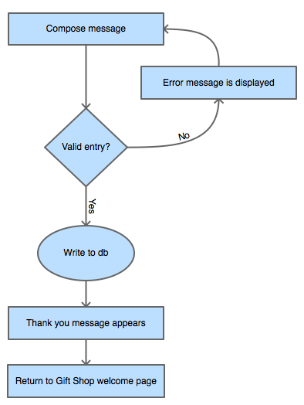

Here is how the “Send flowers to a loved one” dataflow model would look:

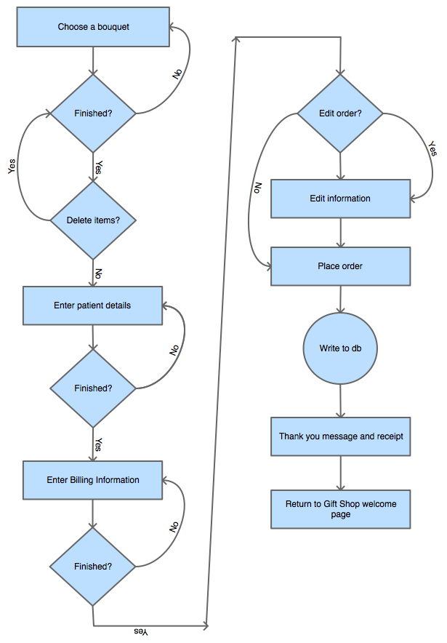

Here is how an administrator would process orders:

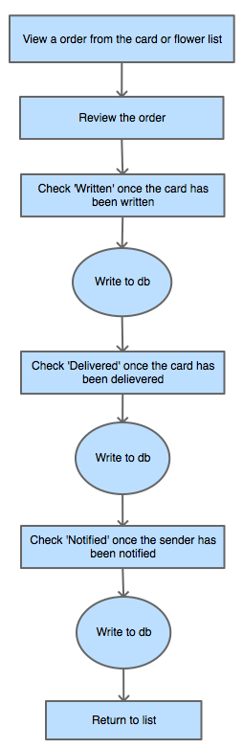

Here is how an administrator would add bouquets from the storefront:

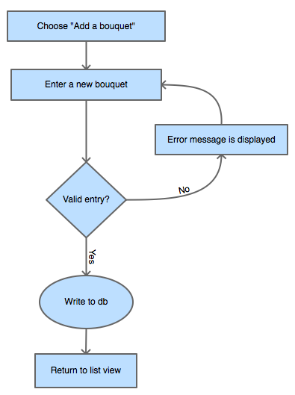

Here is how an administrator would remove bouquets from the storefront:

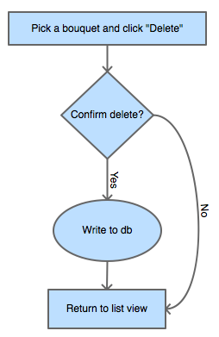

Here is how an administrator would edit bouquets in the storefront:

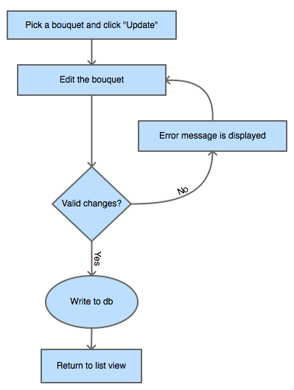

*Wireframes*

Here are the wireframes for the Gift Shop:

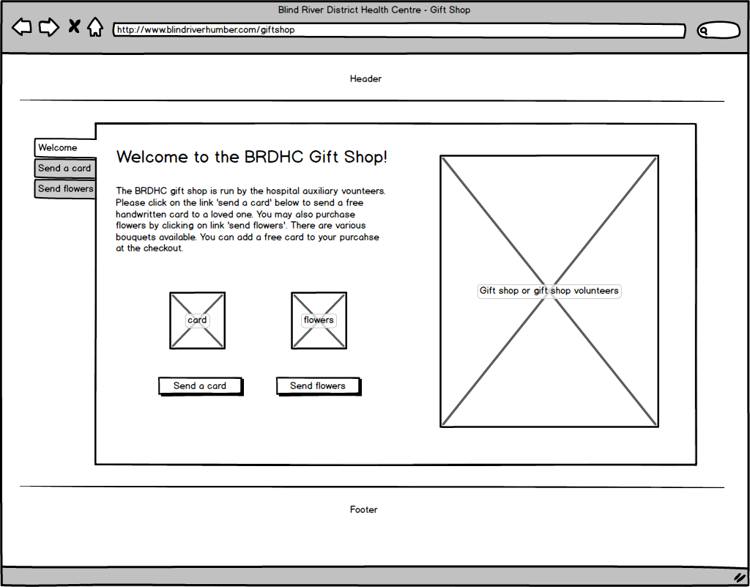

Here is the wireframe for ‘Send a card to a loved one’:

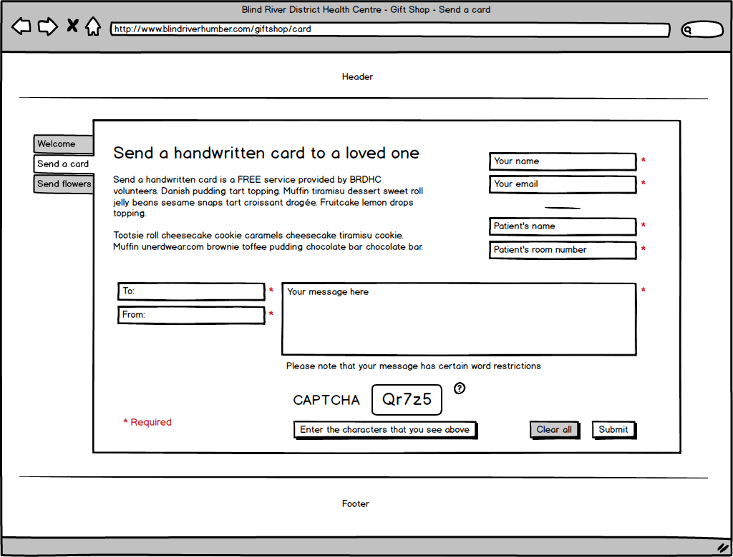

Here are the wireframes for ‘Send flowers to a loved one’:

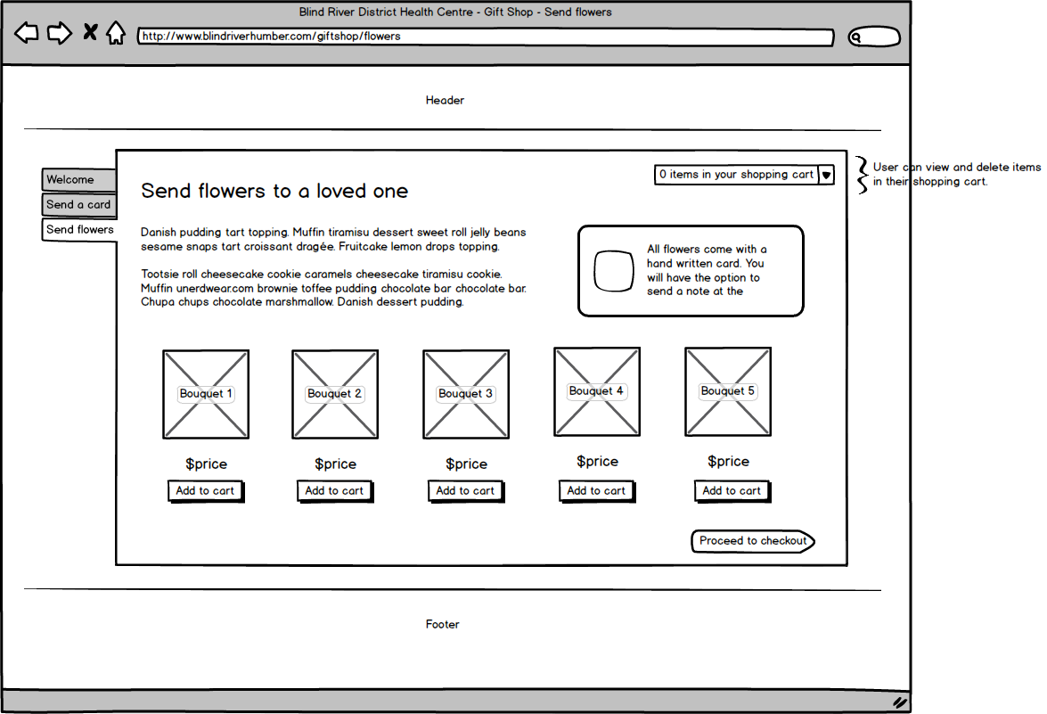

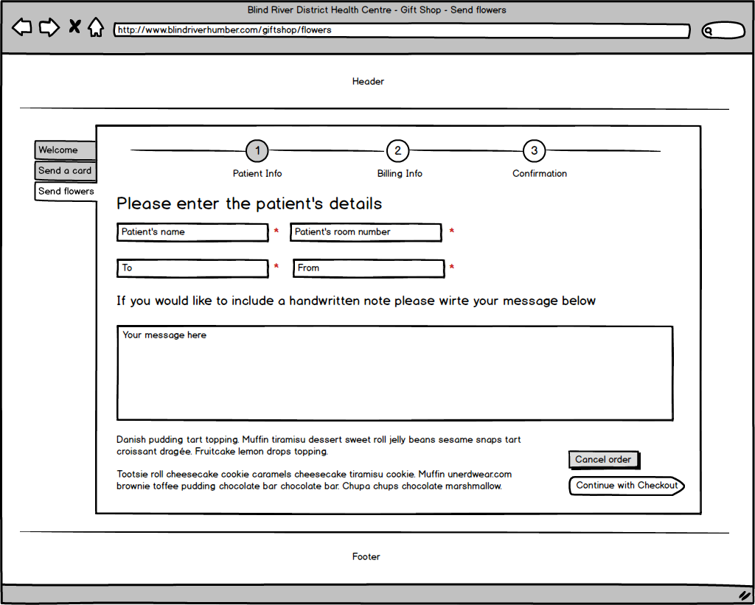

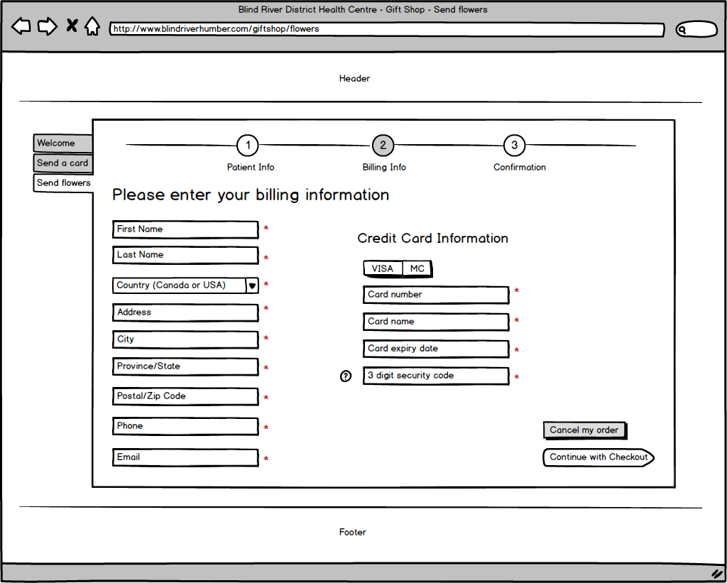

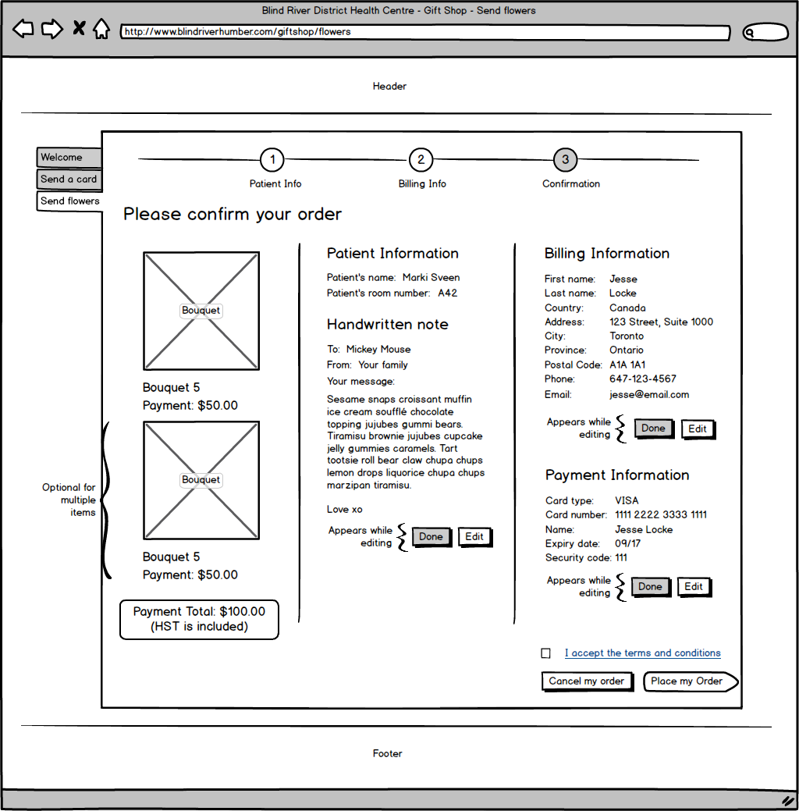

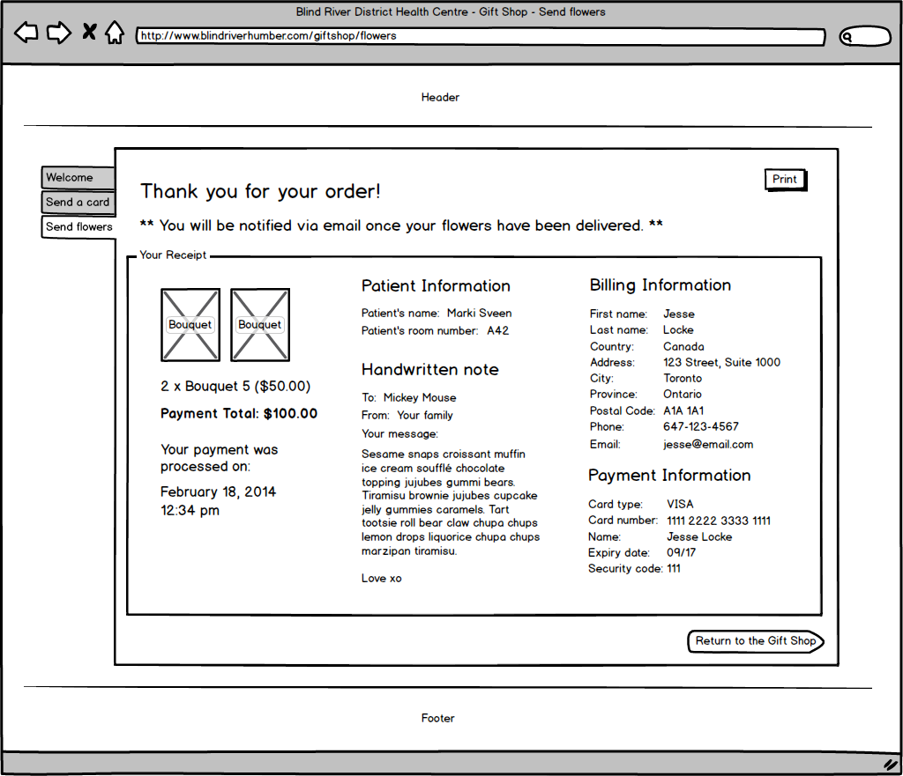

Here is the wireframe for an administrator to process orders:

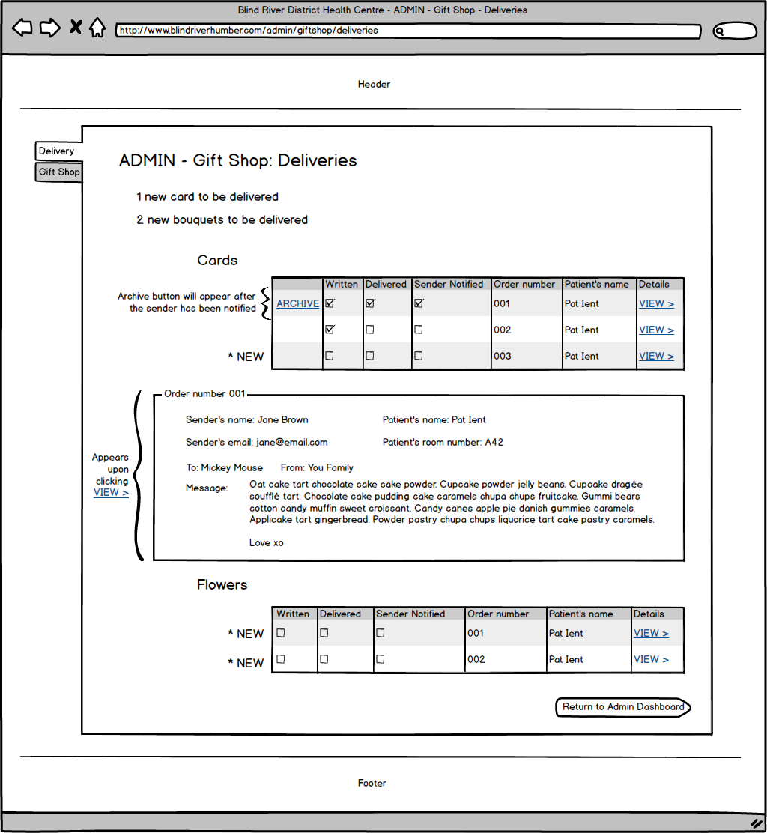

Here is the wireframe for an administrator to add or remove bouquets from the storefront:

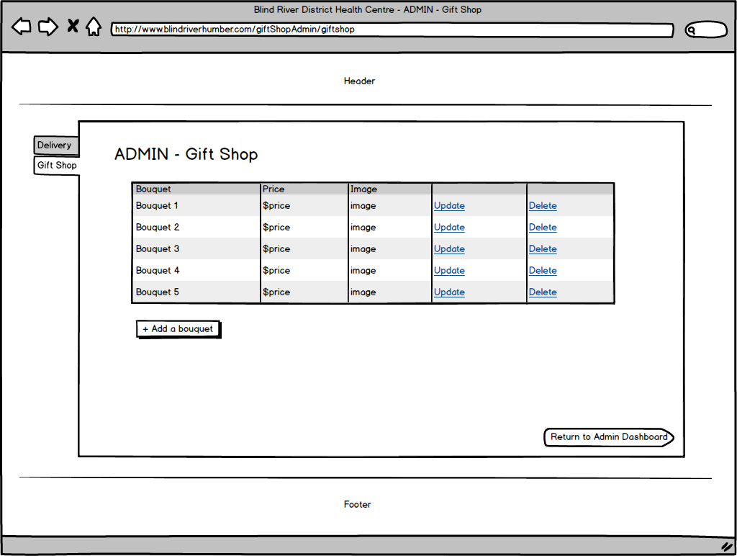

**Marki: Feature 3 - Health Tools**

*Narrative description*

The ‘Health Tools’ feature includes two sub-features: a ‘Healthy Eating Quiz’ and a ‘Smoking Cost Savings Calculator’. Visitors to the website can visit the ‘Health Tools’ page by clicking the link in the navigation menu under ‘Resources’. This service allows visitors to learn about healthy choices in a modern way.

The ‘Health Tools’ feature will have an administrative page for each sub-feature. For the ‘Healthy Eating Quiz’ the administrator will be able to add, remove or modify question-answer pairs in the quiz. For the ‘Smoking Cost Savings Calculator’ the administrator can modify the text for the various “What you can do with (a certain amount of money saved)” and “Health benefits within (a certain time frame) after you quit”.

The databases will look like this:

|  |  |
| --- | --- |
| Question_Id | Unique Identifier (PK) |
| THIS name | Text up to 20 characters |
| THIS image | Link |
| THIS calories | Numeric |
| THIS fat | Numeric |
| THAT name | Text up to 20 characters |
| THAT image | Link |
| THAT calories | Numeric |
| THAT fat | Numeric |
| Answer | Text up to 20 characters |

*Health Tools*

brdhc_HealthTools_Quiz is only one table for Health Tools. Admin add information into this table and it becomes available to public in the form of quiz. Every question has two images, the THIS field and THAT field. The answer column contains the correct answer of the question. Here is the diagram that shows the fields of this table

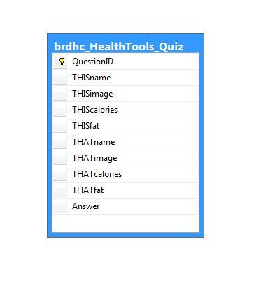

*Dataflow Models*

Here is how the “Health Tools: Healthy Eating Quiz” dataflow model would look:

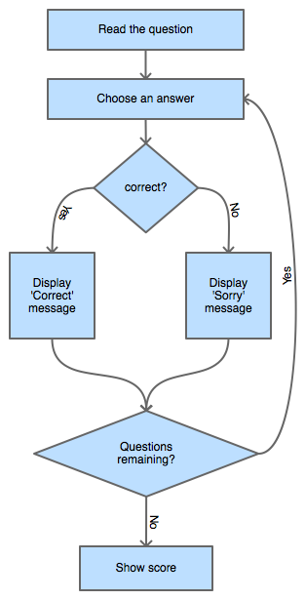

Here is how the “Health Tools: Smoking Cost Calculator” dataflow model would look:

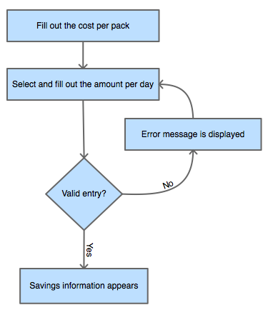

Here is how an administrator would add a question to the quiz:

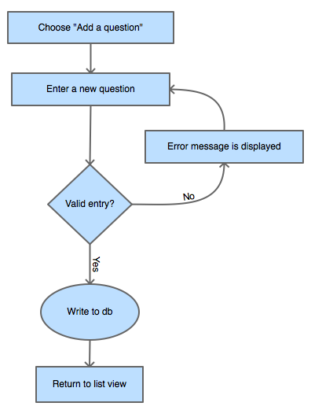

Here is how an administrator would remove a question from the quiz:

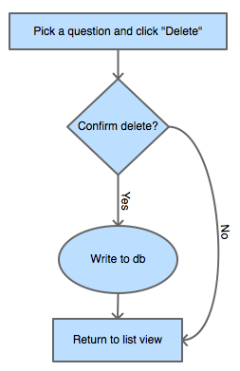

Here is how an administrator would edit a question in the quiz:

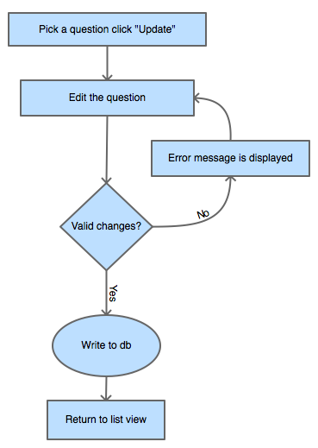

Here is how an administrator would edit cost savings information:

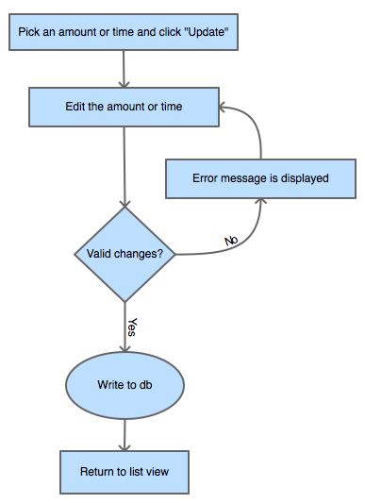

*Wireframes*

Here is how the “Health Tools: Healthy Eating Quiz” wireframes would look:

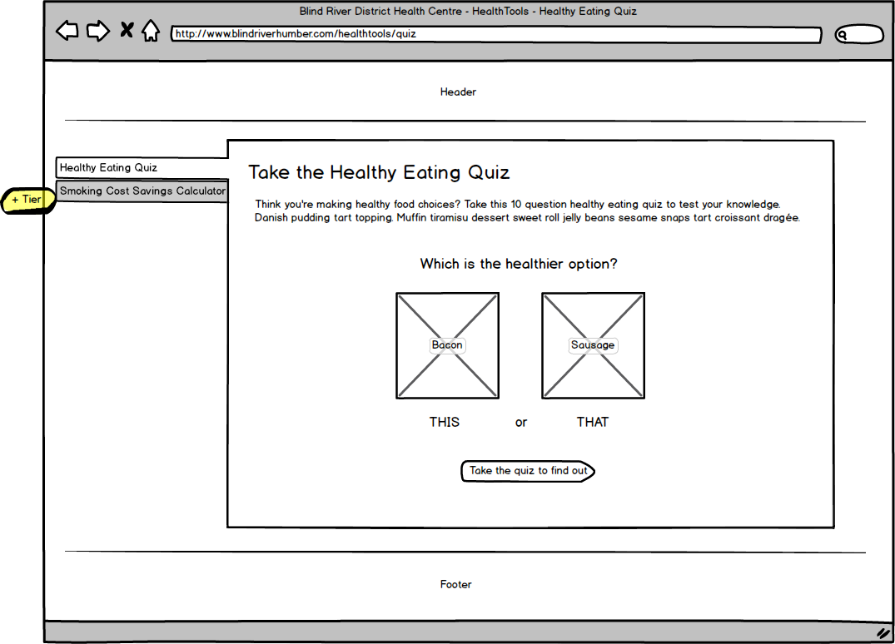

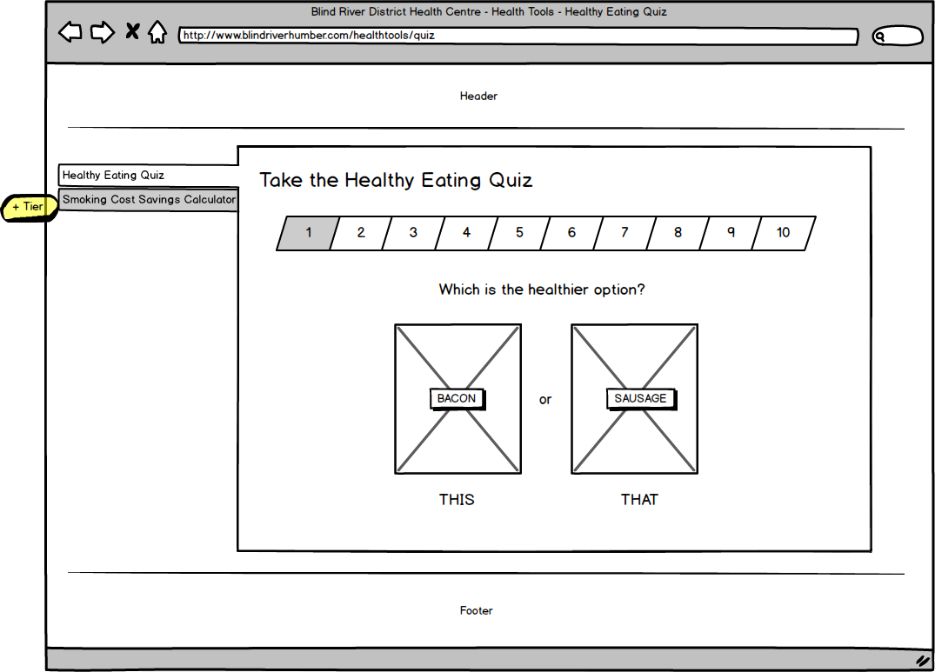

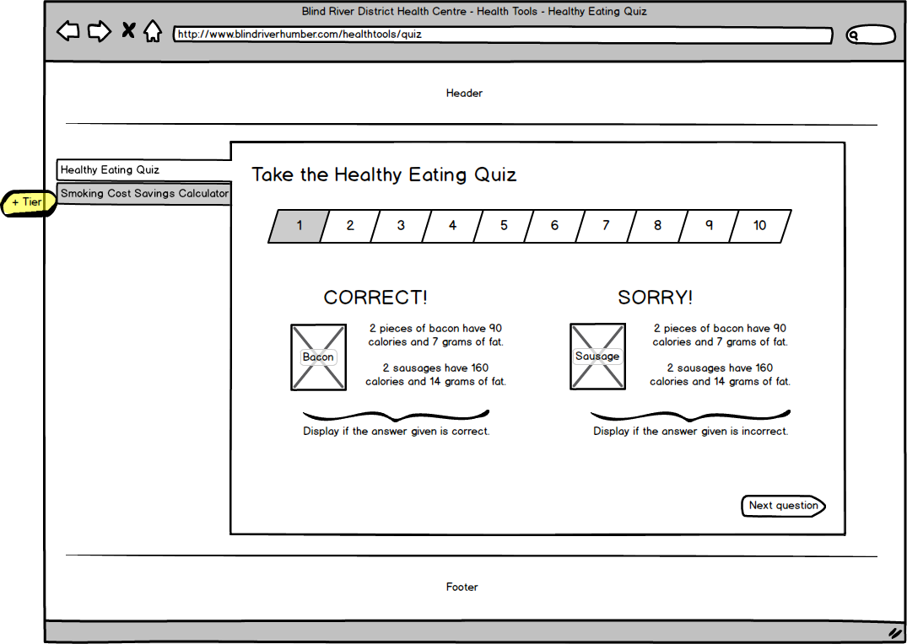

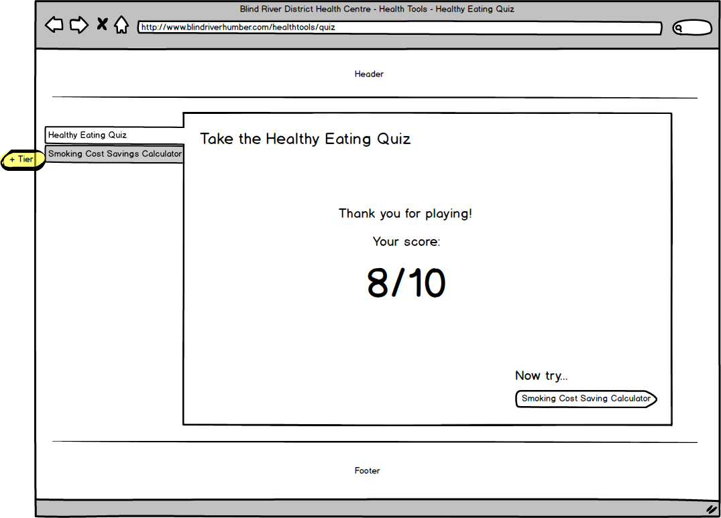

Here is how the “Health Tools: Smoking Cost Calculator” wireframes would look:

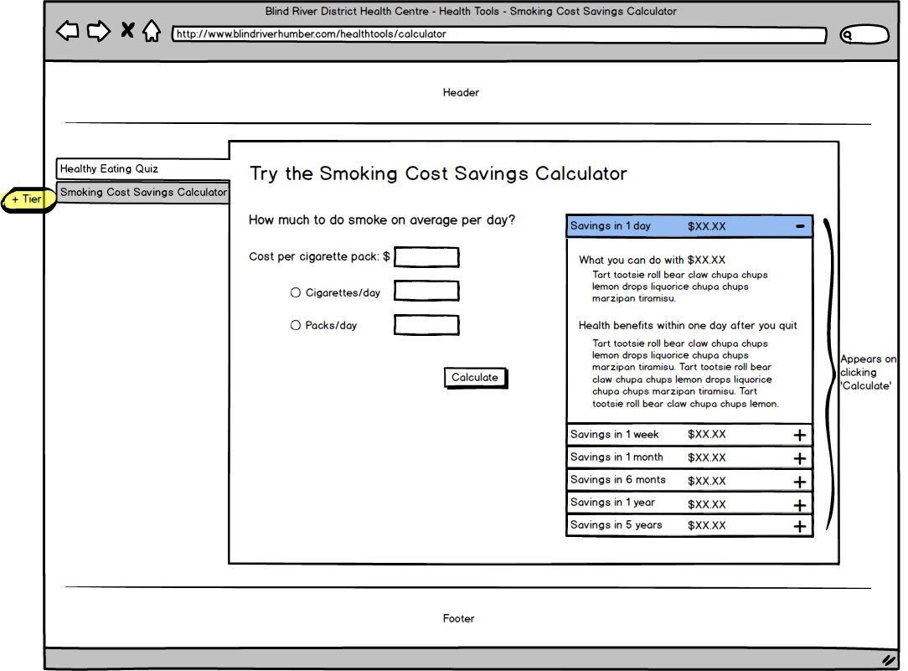

Here is how an administrator modifying the quiz would look:

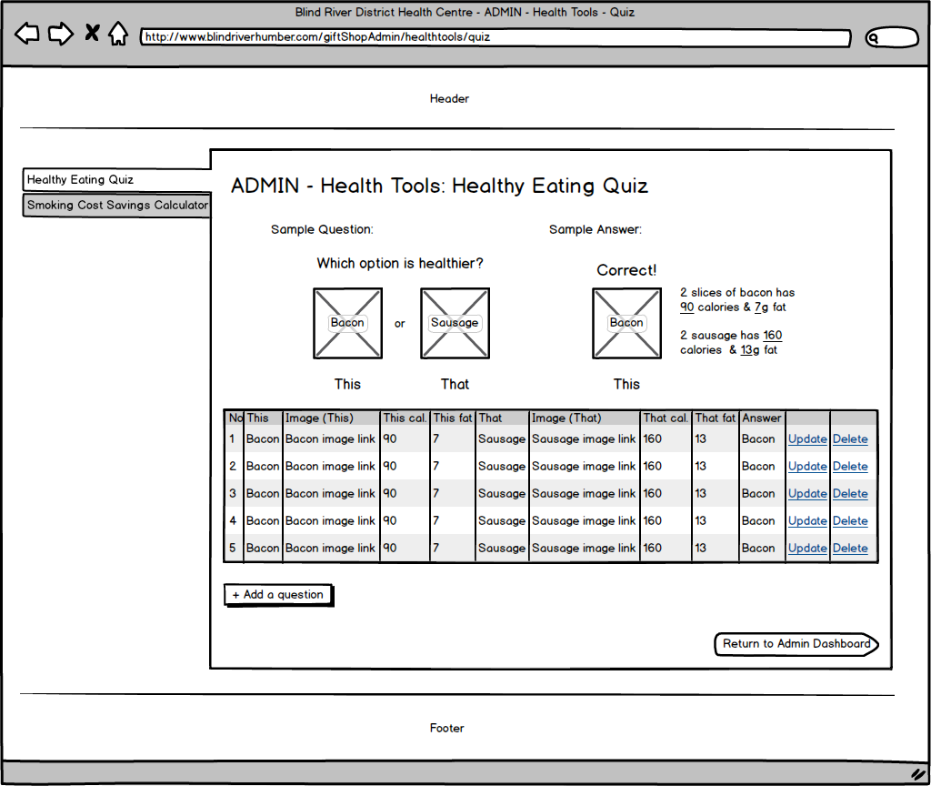

Here is how an administrator modifying the calculator would look:

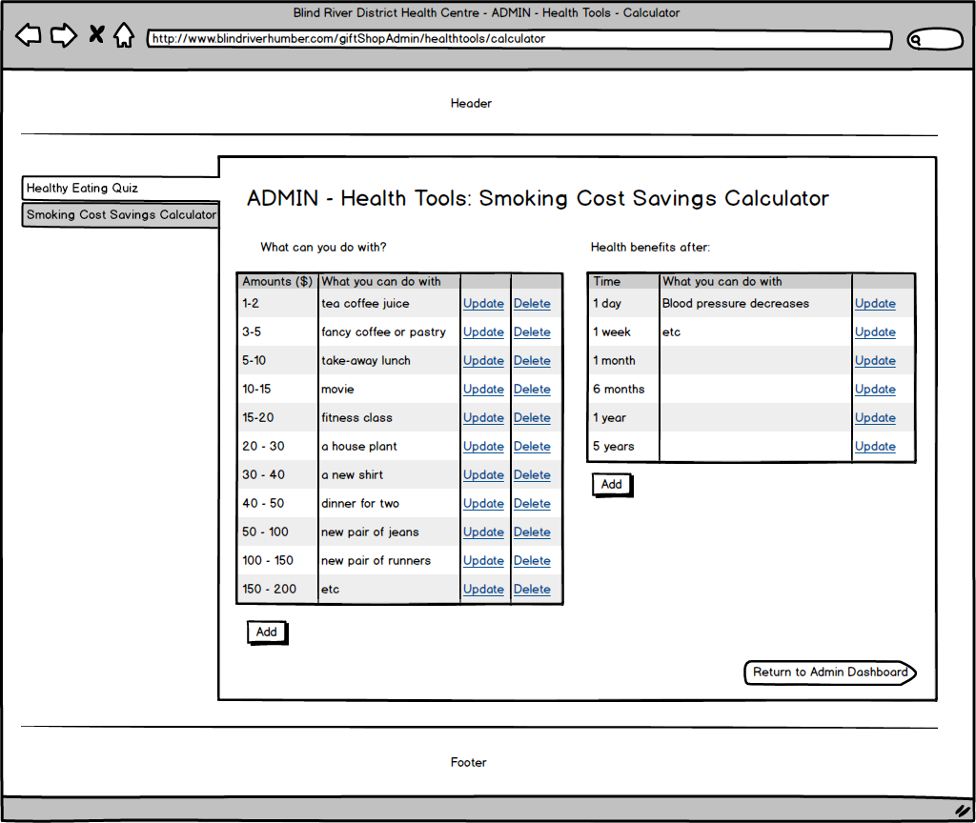

**Ryan Iusi: Feature 1- Contact Us**

The Contact Us page will function as a way for public users to discern the location, and important contact information regarding the hospital. Email addresses and phone numbers will be displayed that users will be able to use in order to contact the Hospital. A map will also be displayed showing the location of the hospital, and input boxes will be made available for users to enter their personal address information which will update the map with directions from that address. The map will utilize Google Maps API to update the map with the correct information.

An Administration page will make it possible for an Admin to update, add and delete Contact Information whenever it may be required.

|  |  |
| --- | --- |
| ContactMessageId | Guid **PK** |
| FirstName | varchar(50) |
| LastName | varchar(50) |
| Email | varchar(50) |
| Phone | varchar(15) |
| Message | varchar(MAX) |
| Subject | varchar(100) |
| IsChecked | bit |
| ContactDate | datetime |
| ReplyDate | datetime |
| ReplyMessage | varchar(MAX) |

*Contact Us*

Contact us page does not have any relationship with any other table. But it has the primary key column (ContactMessageId).

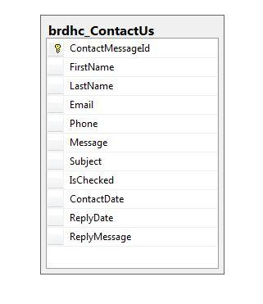

**Data Flow Models**

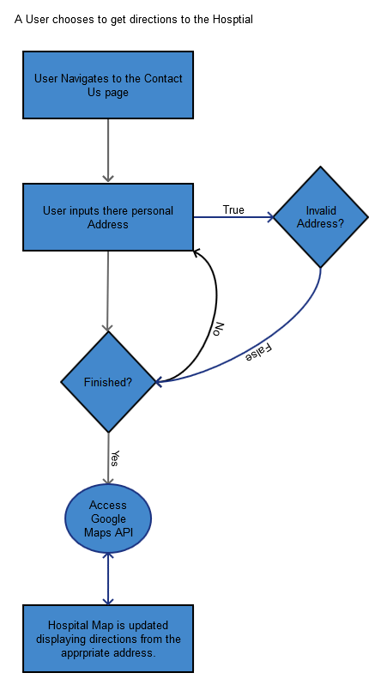

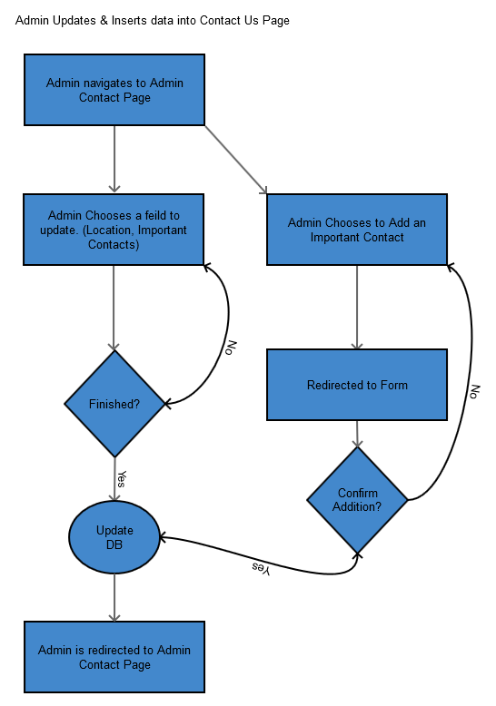

**Wireframes**

Public Page

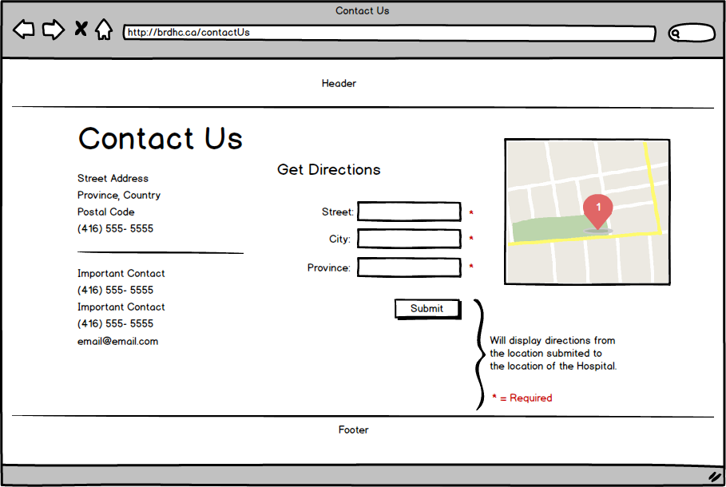

Admin Pages

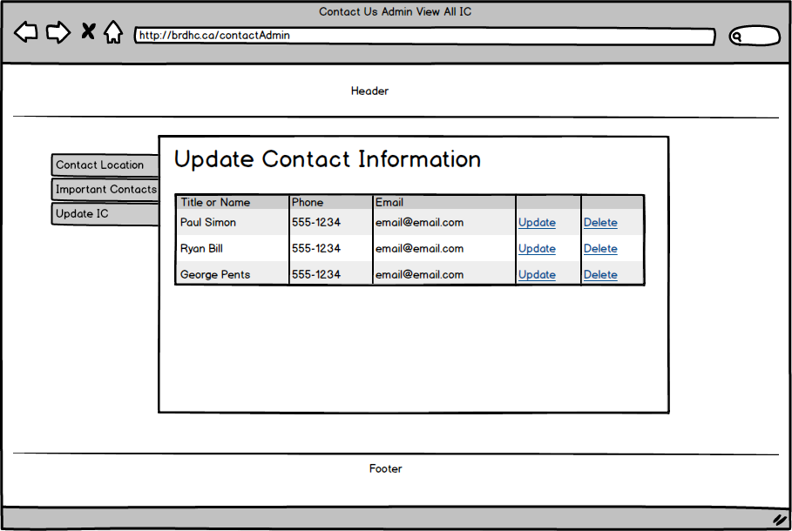

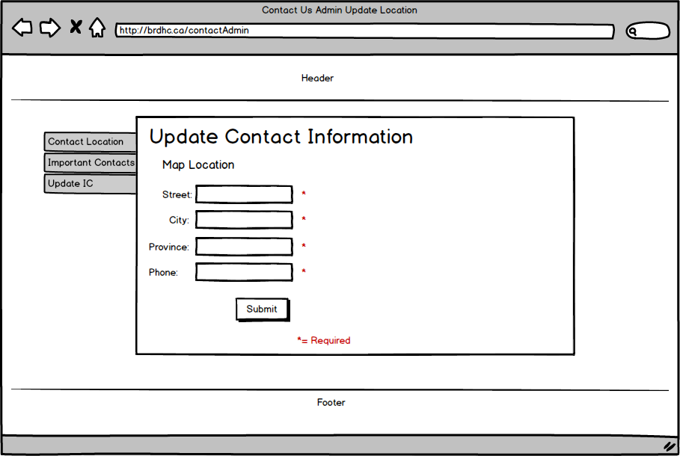

**Ryan: Feature 2 - Events Calendar**

This feature will allow public users to see upcoming community events, as added by the community. Users with the appropriate login roles and Admins will be able to add and update events to the Events Calendar for the community to see. This will be useful for promoting public events, public outreach programs, and community groups and associations.

An Administration backend will allow appropriate users to manage, delete and create new events to be displays on the Calendar. Only users with the right permissions will have access to this feature, as this will prevent abusive and non-relevant events to be posted to the calendar.

|  |  |
| --- | --- |
| EventId | Guid **PK** |
| EventTitle | varchar(50) |
| EventDescription | varchar(MAX) |
| EventCreatedBy | Guid **FK** |
| EventDate | date |
| EventStartTime | varchar(50) |
| EventLocation | varchar(50) |
| EventsHeldBy | varchar(100) |
| IsApproved | bit |
| EventEndTime | varchar(50) |

*Events Calendar*

All events data is stored in brdhc_Events table and this table does not have relationship with other tables. EventId column is the primary key column.

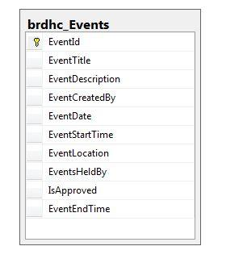

**Data Flow Models**

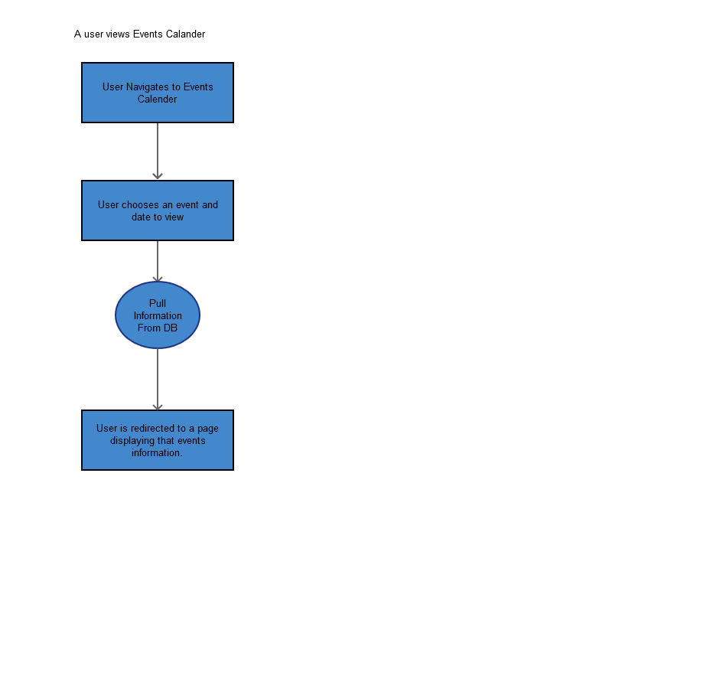

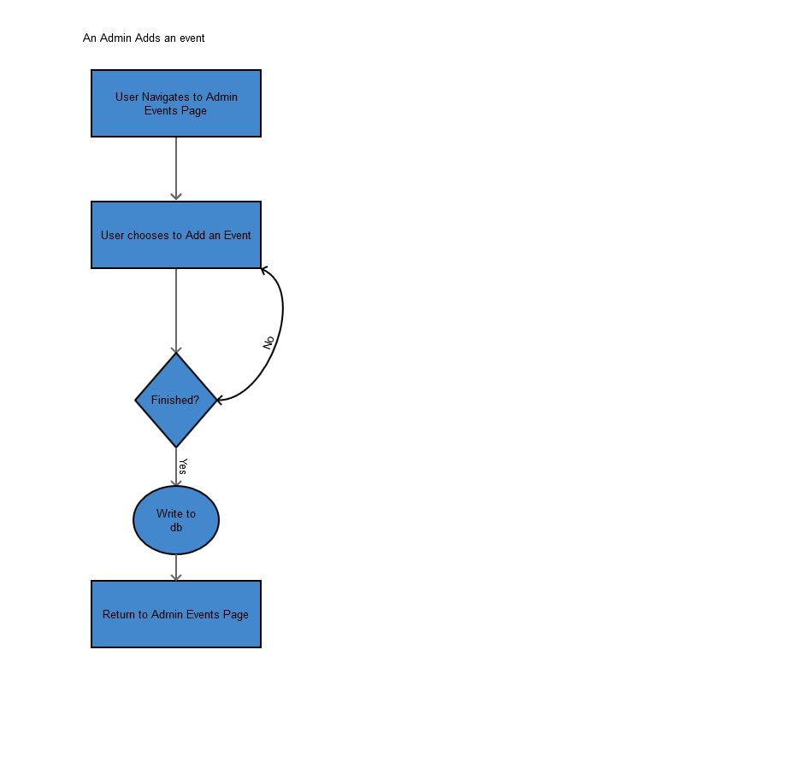

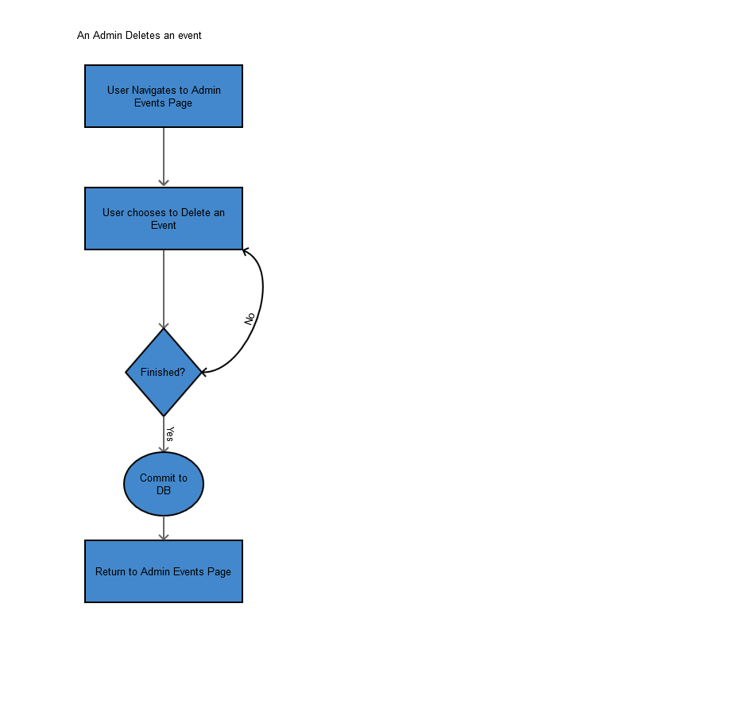

**Wireframes**

Public Side

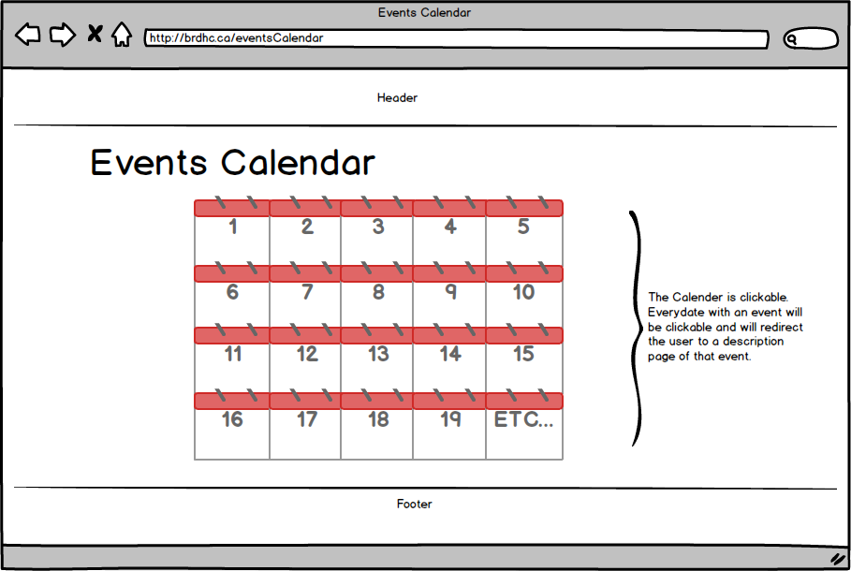

Admin Side

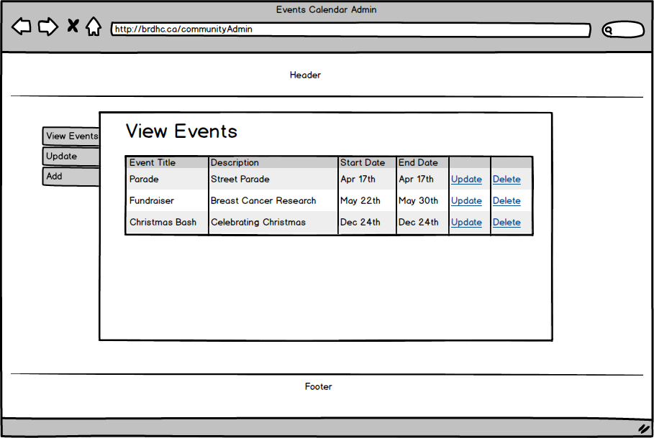

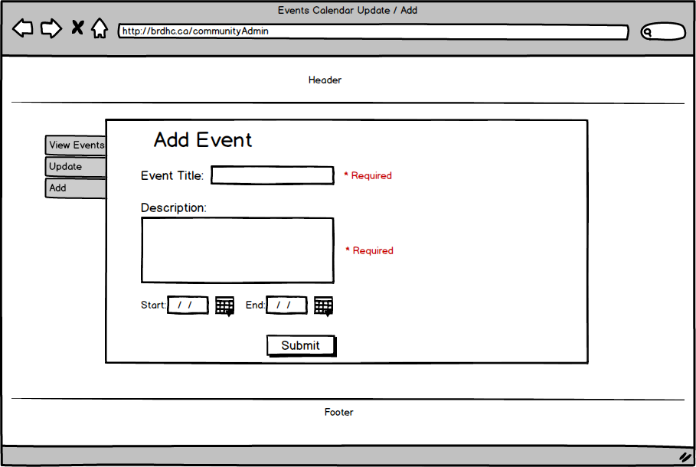

**Ryan: Feature 3 – Careers**

This feature will display career opportunities at the hospital. It will allow public users to view these opportunities, as well as allow them to apply and upload resumes and cover letters to be considered for that position.

An administrative back-end will allow admins to update, add and delete career opportunities whenever appropriate. This back-end will also organize all the applicants to these careers, and allow the admin to easily navigate through these applicants and consider them for the position they have applied for.

|  |  |
| --- | --- |
| ApplicantId | Guid **PK** |
| JobPostId | Guid **FK** |
| FirstName | varchar(50) |
| LastName | varchar(50) |
| Email | varchar(50) |
| Phone | varchar(50) |
| ResumePath | varchar(100) |
| CoverLetter | varchar(MAX) |
| Reply | varchar(MAX) |

|  |  |
| --- | --- |
| JobPostId | Guid **PK** |
| JobPostTitle | varchar(100) |
| JobPostDescription | ntext |
| JobPostingDate | date |
| ExpDate | date |
| ContactEmail | varchar(50) |
| IsActive | bit |

*Careers*

BRDHC Hospital posts jobs online. These jobs are categorised. The Job categories are saved in different table and jobs in brdhc_JobPosts uses theJobCategoryId field from brdhc_JobCategories table for the reference. Similarly when users apply for any posting, record in database table brdhc_JobApplicaitons uses JobPostId field from brdhc_JobPosts table as a reference key. Here is the diagram that shows relationship among tables used for Careers functionality.

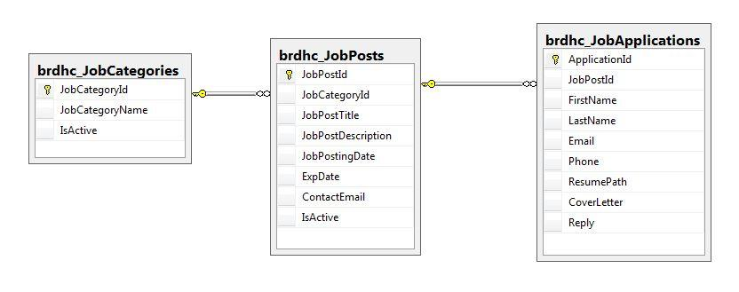

**Data Flow Models**

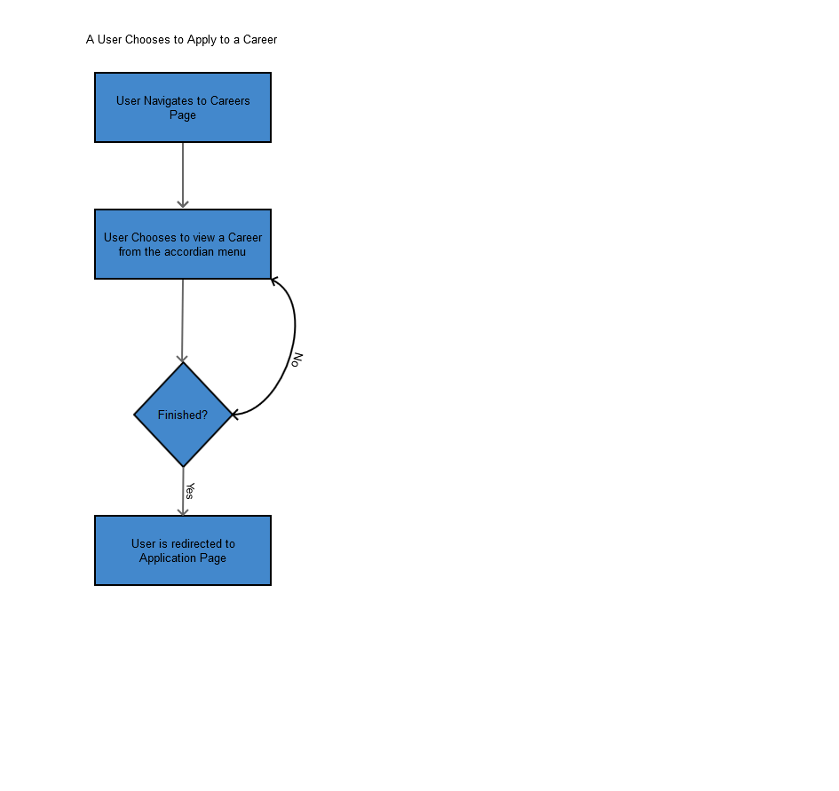

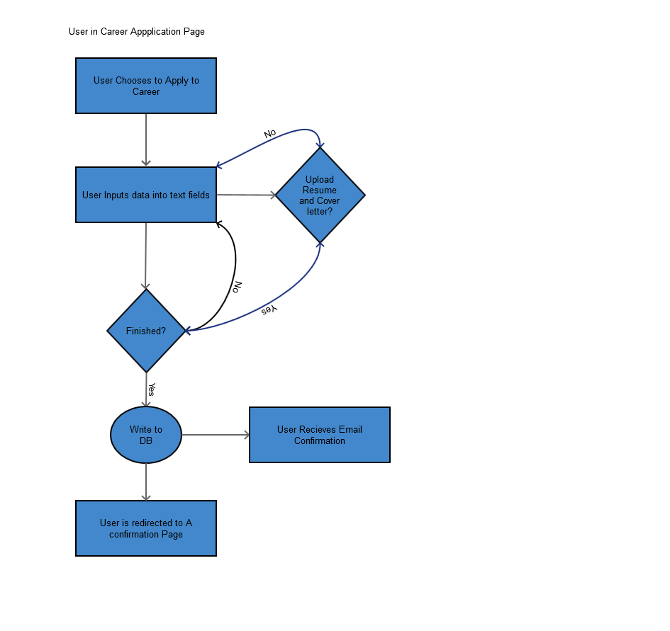

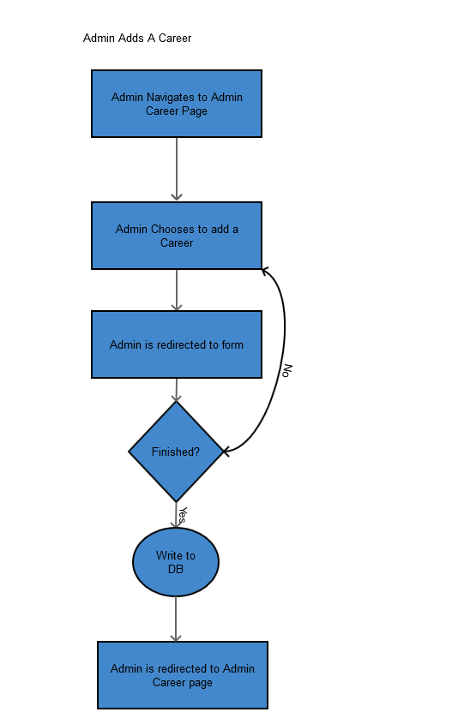

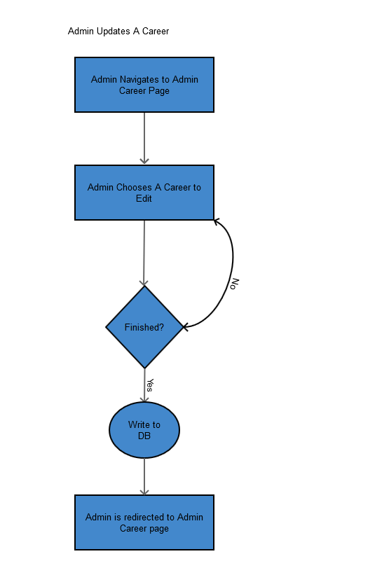



**Wireframes**

Public Pages

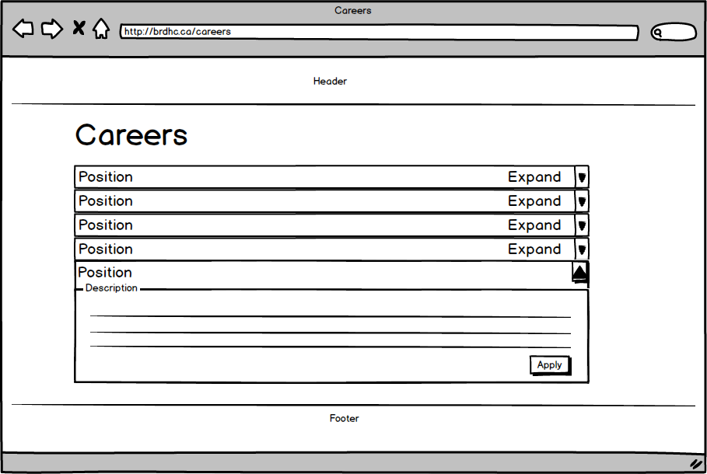

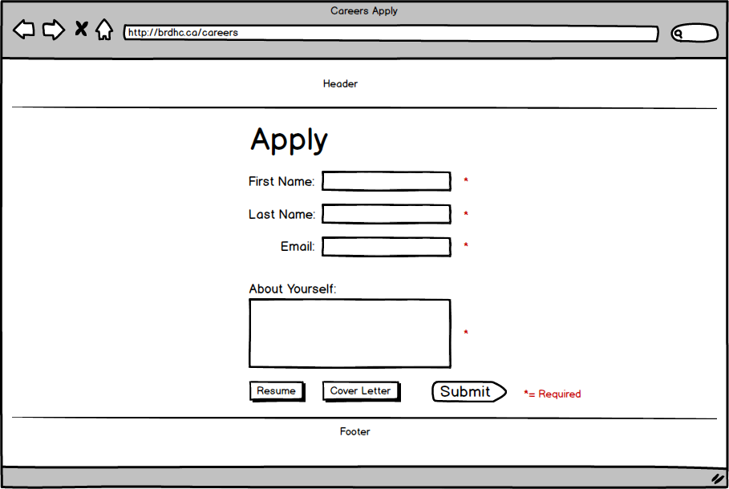

**Admin Pages**

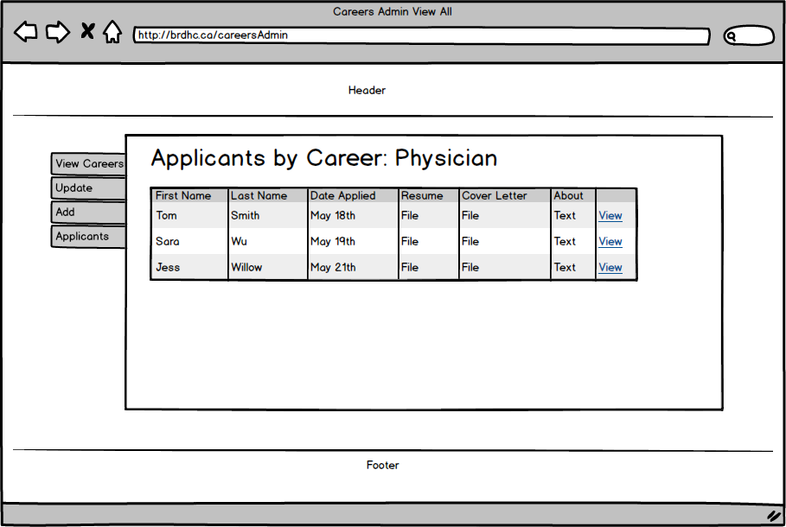

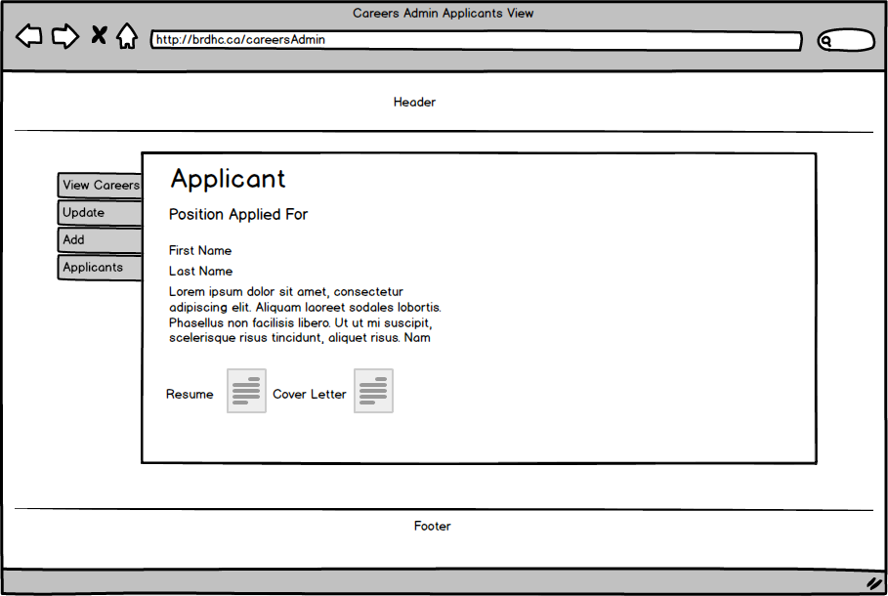

**Section 10 – Development schedule**

We are currently on week 9 on the schedule below.

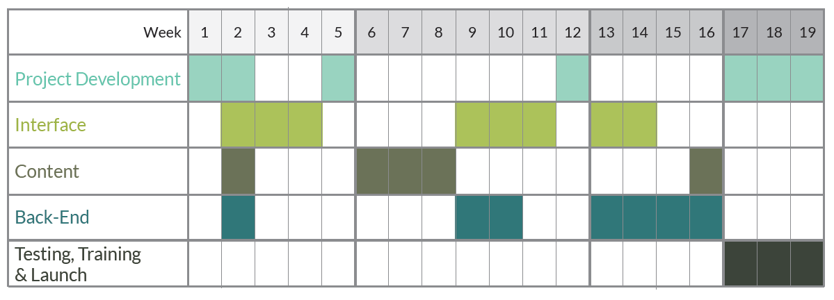

**Section 11 – Maintenance Plan**

|  |  |  |
| --- | --- | --- |
| **Content-Based Tasks** | **Technical Tasks** | **who**  **Performs** |
| · Update news and events  · Add features (paid)  · Add new publications  · Update contacts and organization information  · Update other content as directed by site owner | · Coding as needed | Developer |
| Each month the following tasks will be performed on site, such that each page on the site is maintained 2 times a year:  Review spelling on technical terms  · Review, update, and optimize old content  · Add new content (and optimize)  · Edit content | Each month the following tasks will be performed on the site, such that each page on the site is maintained 2 times a year:    · Spell check (refer technical terms to editor)  · Fix HTML syntax issues; be sure standards are followed  · Be sure special elements (scripts, multimedia, forms, etc.) work  · Ask search engine specialist to reindex any major new sections of content | Developer |
| · Review statistics to learn what pages are popular; update home page or features as needed, based on this info | · Run broken link report  · Review statistics for technical problems | Developer |
| · Review content on every Web page  · Schedule reviews for technical content  · Review special elements to decide if they are still necessary  · Review major content sections to decide which are still necessary; decide if need new content sections  · Collect end-of-the-year website data, such as statistics or data from user-centered design projects. | · Decide if redesign is necessary (from a technical standpoint)  · Clean up directory (remove orphan files, etc.)  · Update date stamp after content review | Developer |

**Section 12 – Handover Plan**

Under the conditions that extensive testing is completed, and any and all potential redundancies and exploits are dealt with, we will begin the process of handing over the web site. This process will involve the choosing of select individuals on your behalf to begin training sessions with our team. The primary focus of the training sessions will be to allow these individuals to become experts in the CMS we’ve created, and give them the confidence to teach other staff the members as well.

**Training Sessions:**

Depending on the circumstances, training may take as little as one 2-3 hour training session or as many as three as these sessions. We’re confident that training will take the minimal amount of time as we’ll also create an extensive user manual for our CMS.

**User Roles:**

Determining user roles and administrative privileges will also be chosen on your behalf. We’d recommend that user roles are chosen to mirror or match the employment hierarchy of the Hospital, as confidential information will be stored in the database.

**The Handover:**

Once the training phase is done and user roles have been determined, the Hospital website will go live and will be available to internal and public. No hard copy will be delivered, as the final product will be completely digital and hosted online. At this point our development team will also handover administrative privileges, and it’s recommended you change any and all passwords for your own protection.

**Section 13 – Personas**

|  |  |  |  |  |
| --- | --- | --- | --- | --- |
| ***Category*** | **Persona #1** | **Persona #2** | **Persona #3** | **Persona #4** |
|  |  |  |  |  |
| **Name** | Chase O’neil | Chris Clarkson | Colleen Martel | Olenna Redwyne |
| **Age** | 15 | 65 | 45 | 90 |
| **Gender** | Male | Male | Female | Female |
| **Ethnicity** | Francophone | First Nations | Caucasian | Danish |
| **Education** | Enrollled in HighSchool | Highschool Certificate | BA in Communications | Primary school |
| **Occupation** | Student | Retired Truck Driver | Bank Financial Specialist | Retired Farmer |
| **Relations** | Lives with Parents. Only child. | Lives alone. Has 3 children and 2 grandchildren. | Lives with Family. Has a Husband and 2 children. | Lives wih her Daughters Family. Has 3 grandchildren. |
| **Hobbies** | Gaming and Video Blogging | Hockey, fishing and Hunting | In a Women's Quartet singing group. | Crochet |
| **Fears** | Losing the internet and not being up to date. | Getting his identity stolen. | Home invasion. | Losing touch with people. |
| **Goals** | Moving out, getting into college and blwoing up on the internet. | Laying back and enjoying retirment. Also winning the championship in his men’s hockey league. | Working towards a retiremnt fund and vacationing. | Going out more and getting involved in the community. |
| **Health** | Modestly healthy. Eats fatty and sugery foods. | Has Diabetes, and is a chain smoker | Very health. Gluten Free. | Has Diabetes but has no other major health risks. |
| **Religion** | Agnostic. | Non-observant Christian | St. James the Creator | Baptist |
| **Internet Speed** | 4G | 3G | 4G | 3G |
| **Browser** | Chrome | IE7 | IE7 & Chrome | Safari |
| **Computer Literacy** | **High:**  Has a high end gaming PC and always upgrading. Always up to date with his browser, and knows a minimal amount of HTML | **Low:**  Given a PC by his family to stay in touch. Never updates browser for fear of installing something melacious. | **Medium:**  Works with IE7 at work due to application restriction. At home she uses Chrome, and can easily navigate the internet. | **Low-Medium:**  Given a iMac by her children. Since she lives with one of her childrens family, they make sure to keep her computer updated at all times. She is able to easily use facbeook to connect with friends and family, but she is not familiar with surfing the internet. |